

AWS Labs 1-3

Aaron Yu

Lab Partners: None

Cisco CCNP

Introduction

# Purpose

The purpose of these labs is to put knowledge of Amazon Web Services (AWS) learned through the course’s videos into the actual console through preconfigured environments to learn aspects of the different web services provided by AWS, including Identity and Access Management, Virtual Private Cloud, and Elastic Compute Cloud.

# What is AWS?

Amazon Web Services is a service made by Amazon that provides pay-as-you-use cloud computing. This model is useful as this allows for people in need of these services but are unfamiliar with how these things work to be able to invest less at first and increase infrastructure as needed, as AWS allows for easy maintenance and scalability. In essence, AWS allows for a very dynamic infrastructure, able to adapt new applications or systems in minutes, and allow for no money being wasted on excess equipment.

Lab 1 – Introduction to AWS IAM

# Purpose

The purpose of this lab is to introduce AWS’s Identity and Access Management (IAM) by observing premade users, user groups, and group policies in an IAM configuration to learn how IAM functions.

# Background Information

AWS IAM is a web service that oversees the permissions of different roles through a centralized application and can edit and view permissions of these different roles for desired configurations according to the customer’s need. IAM achieves this through policies, of which there are three kinds introduced in the lab.

* **AWS managed policies** are policies made and managed by AWS and are common templates that are used for common policies such as giving a several groups of users read only access. These policies are preconfigured so there is no need to write these policies yourself, so time is saved.
* **Customer managed policies** are policies for the customer’s own specific needs, of which these policies are still templates for multiple users/groups. Many of these policies are just a derivative of some AWS managed policy with some slight tweaks to fit customer needs.
* **Inline policies** are policies also for the customer’s own specific needs, but these policies are made for only a specific user or group, and reside within these users and groups, so if a user/group with an inline policy is deleted, the inline policy is deleted as well.

These policies are made up of statements which contain three variables – Effect, Action, and Resource – where the Effect specifies if the permission is allowed or denied, the Action specifies the API the statement is referring to, and the Resource specifies the scope of entities affected by the statement.

# Lab Summary

In this lab we viewed premade IAM users and groups that with applied policies (two AWS managed policies and one inline policy) and added users to the different groups then signed in as those users and compare the differences in the console for these users.

# Configurations

After starting the lab and opening AWS, the AWS console is opened, and the dashboard should be displayed. In the top left, there is the Services menu next to the AWS logo:

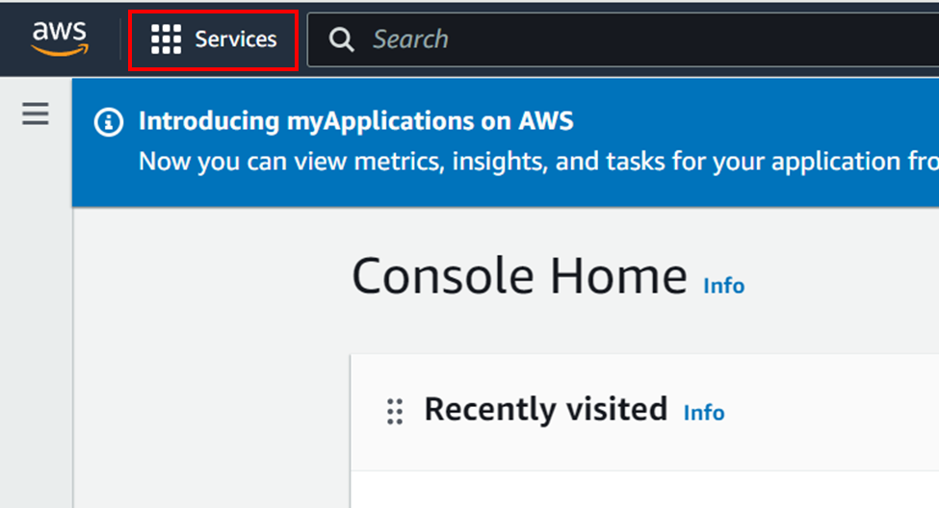



Opening this menu displays the services AWS provides. Going to All Services and navigating to the services starting with “I”, IAM should be the first result.

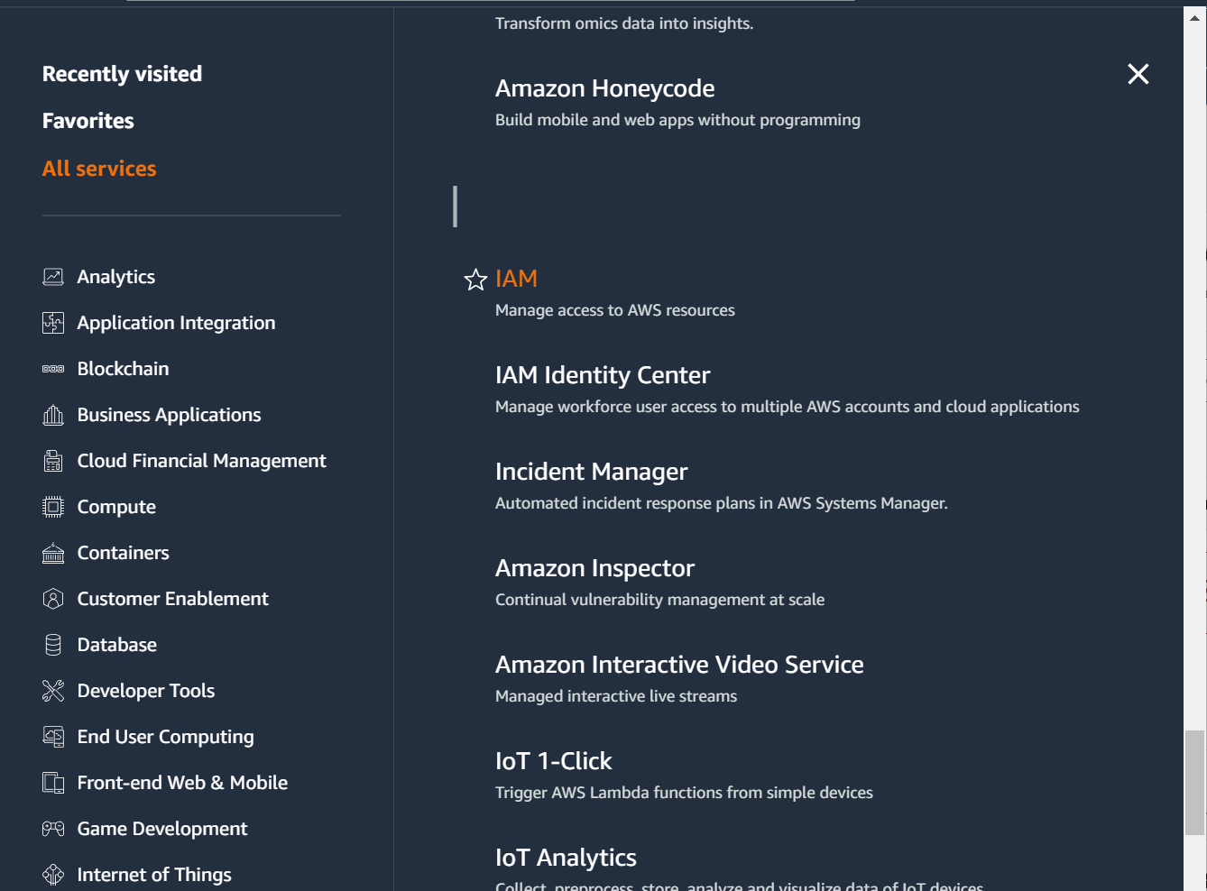

After opening the IAM console, the IAM dashboard should appear with a navigation bar on the left.

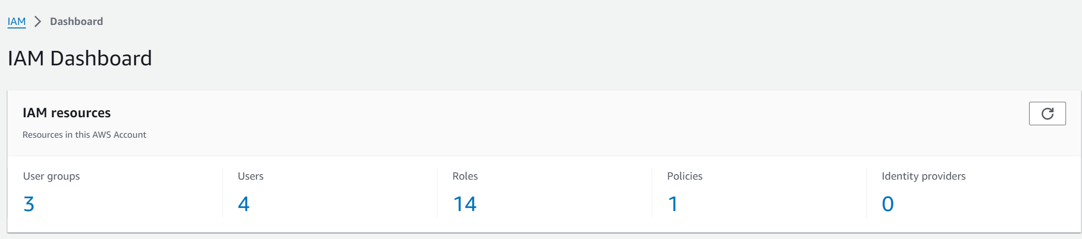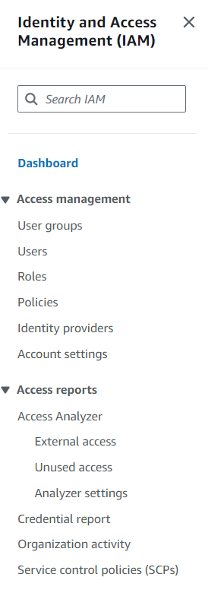

We can observe that there are currently three user groups, four users, and one policy, but it is worth noting that one of these users is not relevant to the lab.

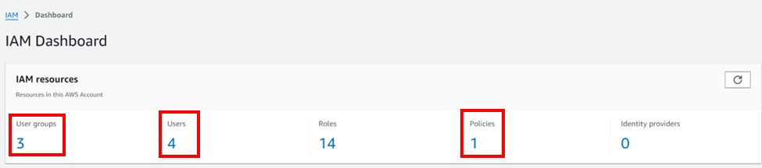

Go on to view the IAM users. The users can be viewed from either the dashboard by clicking the “4” under Users or by going to the sidebar and pressing Users.

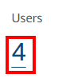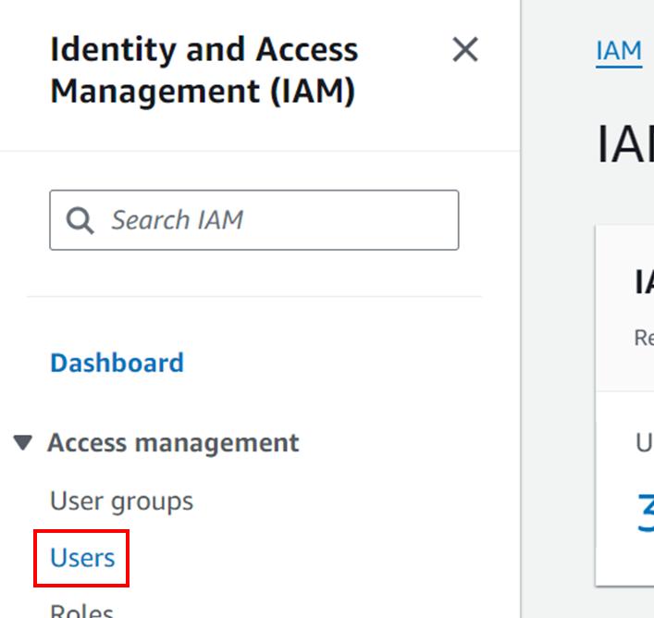

The following page should be displayed, and information about the users can be viewed from here, including name, path, group, activity, and security details. We can see the four users, where the user awsstudent will be irrelevant for the lab.

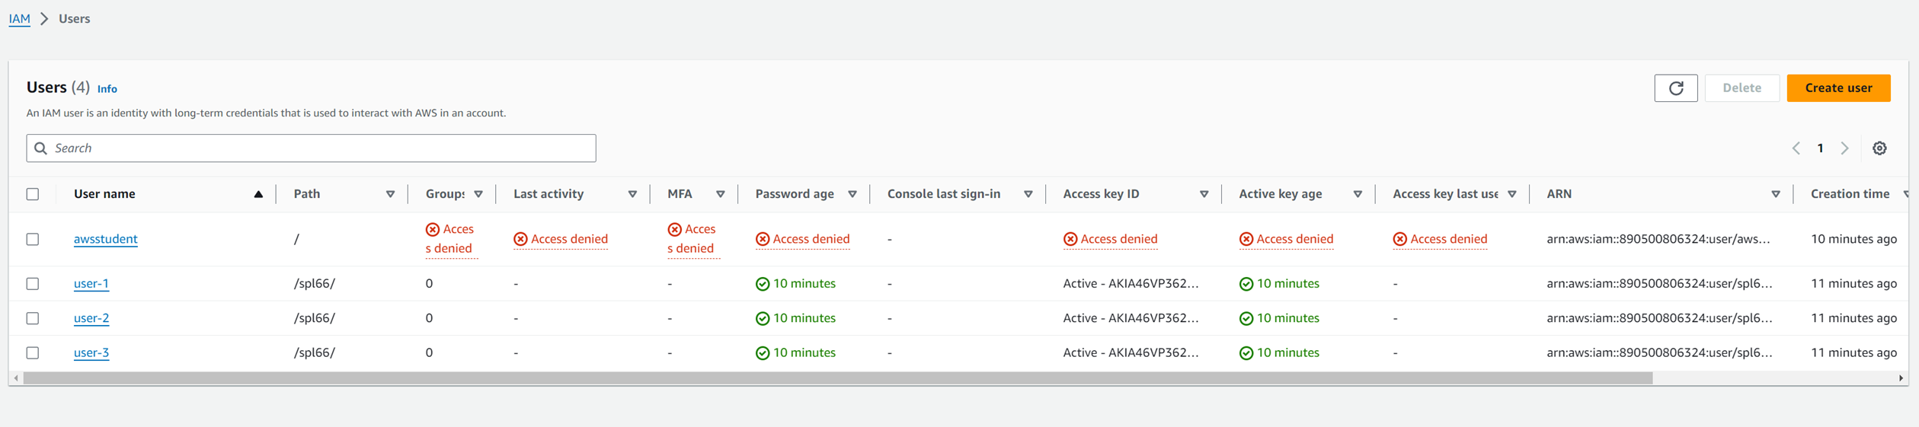

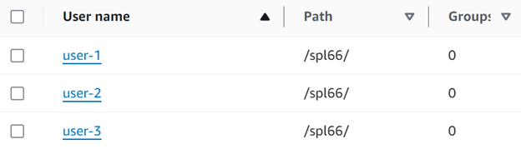

(awsstudent has been edited out for visual purposes)

Clicking on one of the names will provide even more details. Click user-1:

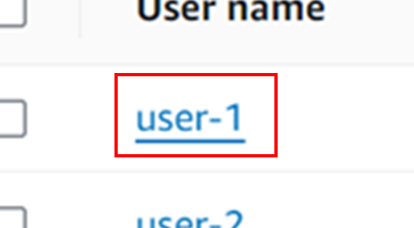

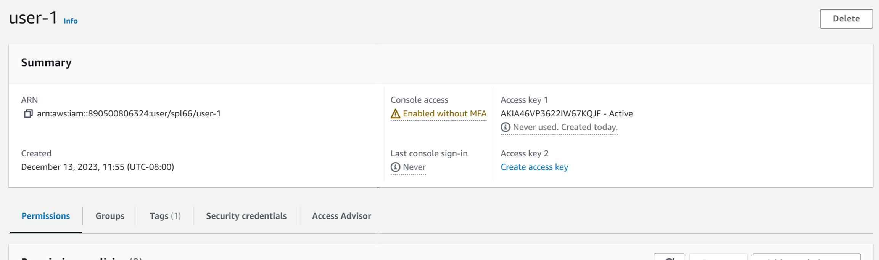

Under the summary, the permissions for user-1 are displayed. user-1 has no permissions.

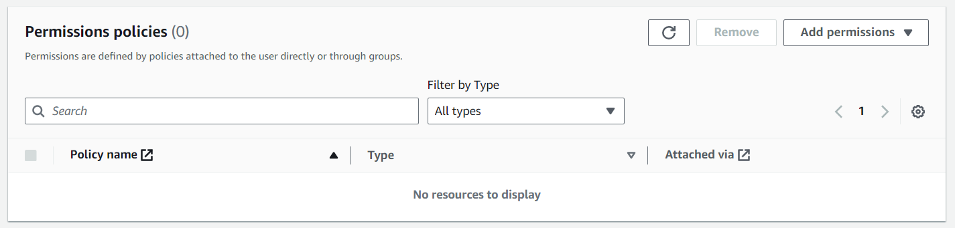

Changing to the Groups tab, we will also see that user-1 is in no groups.

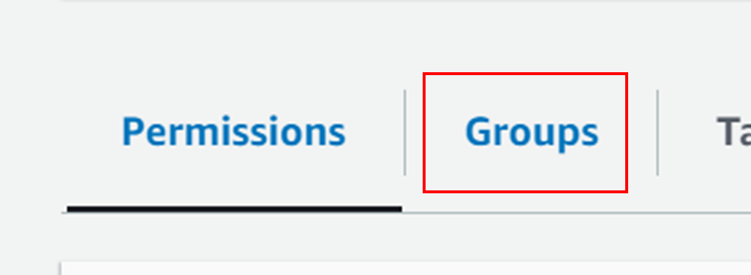

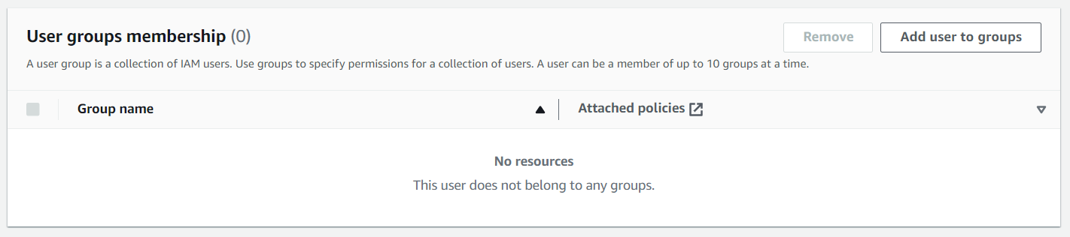

Changing to the Security Credentials tab, we will be able to see the sign in link for this console and that user-1 does have need a console password to log in, and that user-1 has never signed into the console.

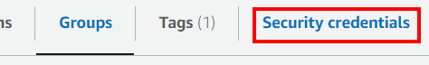

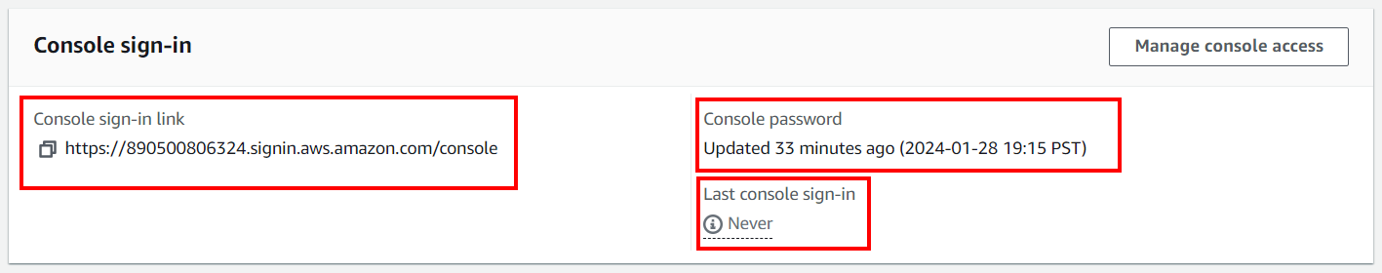

We will now view the user groups. To navigate to the user groups, focus back on the left sidebar and select User Groups.

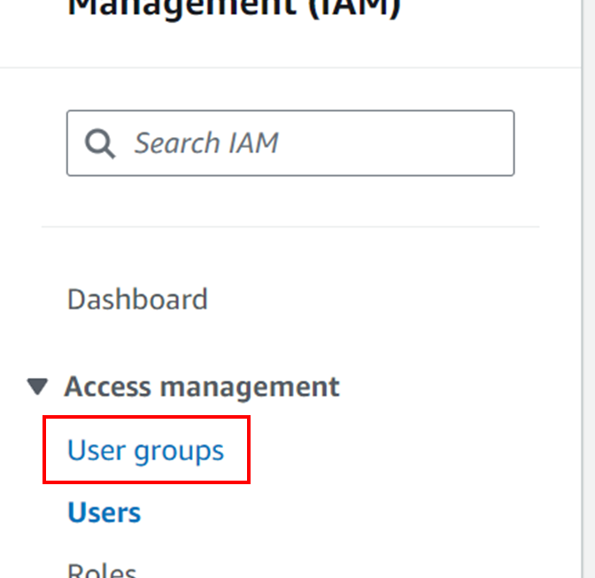

The user groups screen, similar to the users screen, will display information about the user groups. We can see there are three user groups named EC2-Admin, EC2-Support, and S3-Support, each with zero users and defined permissions.

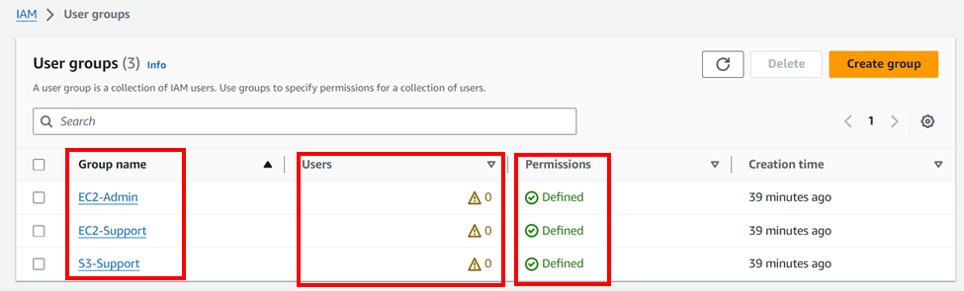

Clicking the EC2-Support group, we can see the summary and tabs currently displaying users in the group.

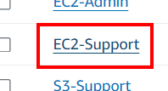

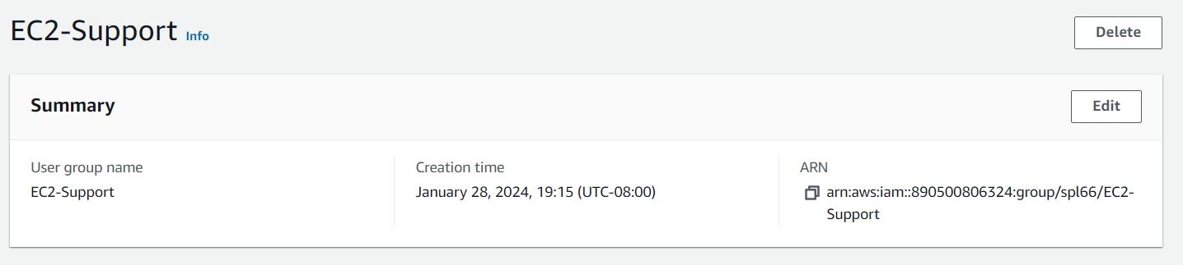

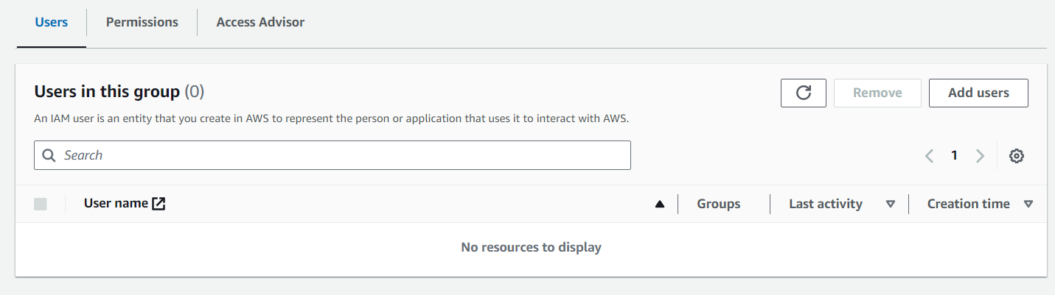

Changing to the Permissions tab will reveal the policies attached to the group, and the type and attached entities of those policies.

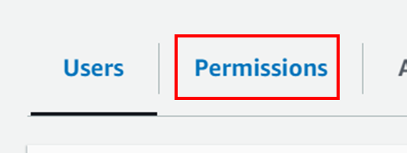

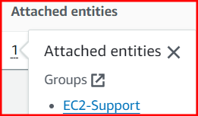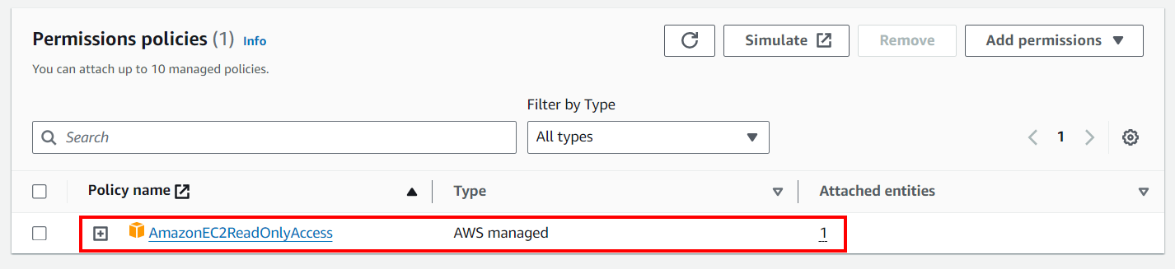

As we can see, AmazonEC2ReadOnlyAccess is an AWS managed policy, meaning it is not modifiable by the customer, and was made by AWS to be ready-to-use. The policy has one attached entity, which is the EC2-Support group.

Pressing the  button expands the policy and displays the description of the policy and the JSON for the policy.

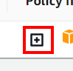

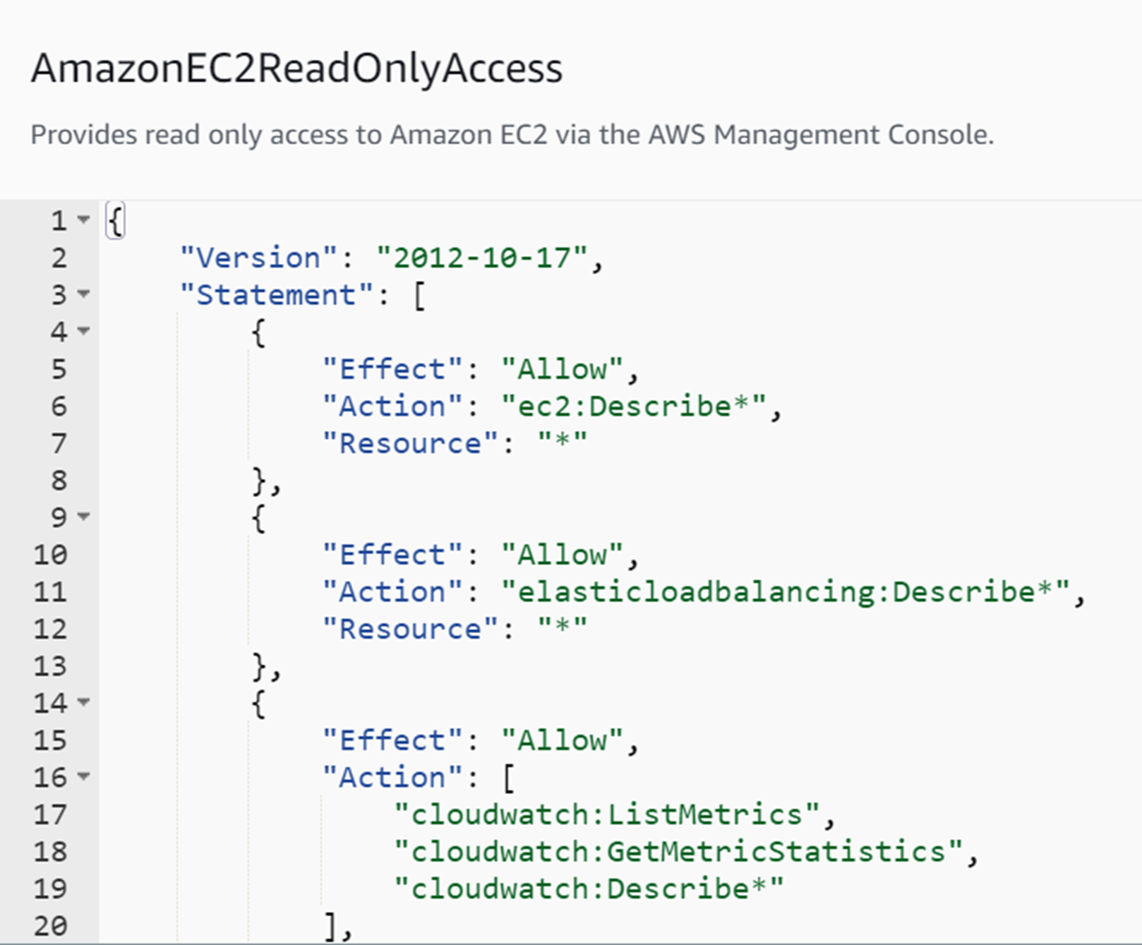

Here we can see the structure of these policies and what each policy does. For AmazonEC2ReadOnlyAccess, the first statement allows users with the policy the ec2:Describe permission.

Pressing the  button collapses the policy.

Now repeat the process on the other two groups.

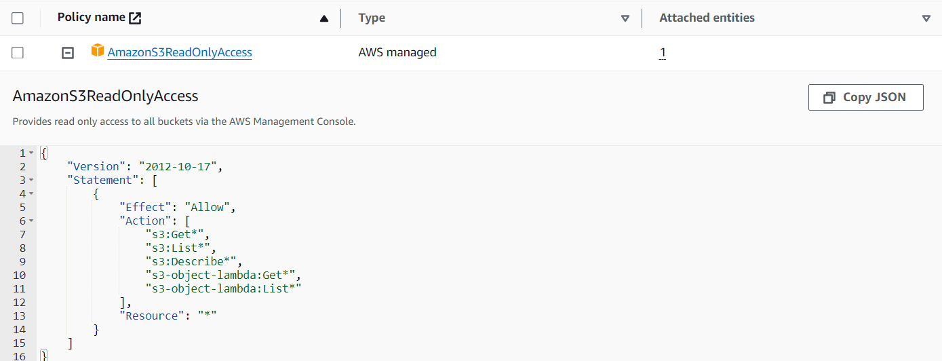

AmazonS3ReadOnlyAccess is also an AWS managed policy but has different permissions than AmazonEC2ReadOnlyAccess.

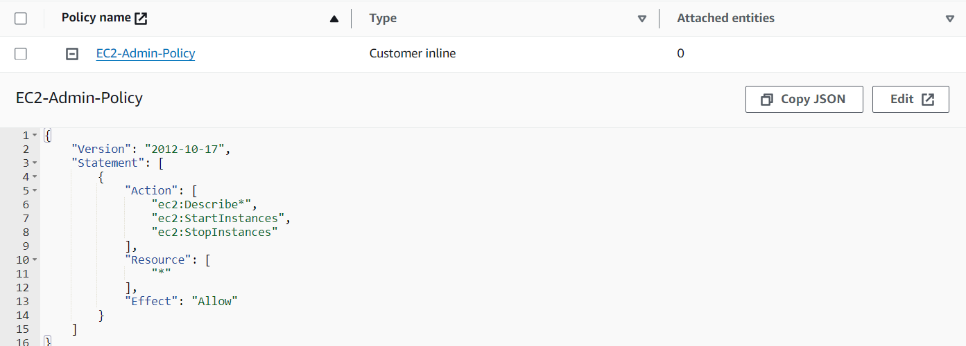

As we can see, EC2-Admin-Policy is a customer inline policy, meaning it is only made for the group and cannot be applied to other entities unrelated to the EC2-Admin group. Because it is within the group, it has no attached entities because there are no users in any groups yet.

Now we will add the users to these user groups. We will add user-1 to S3-Support, user-2 to EC2-Support, and user-3 to EC2-Admin.

We can go back to the user group screen by pressing User groups under the search bar or in the left sidebar.

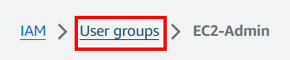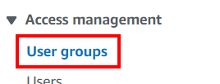

Go back into S3-Support and focus on the Users tab. Click the button on the top right labeled “Add Users”.

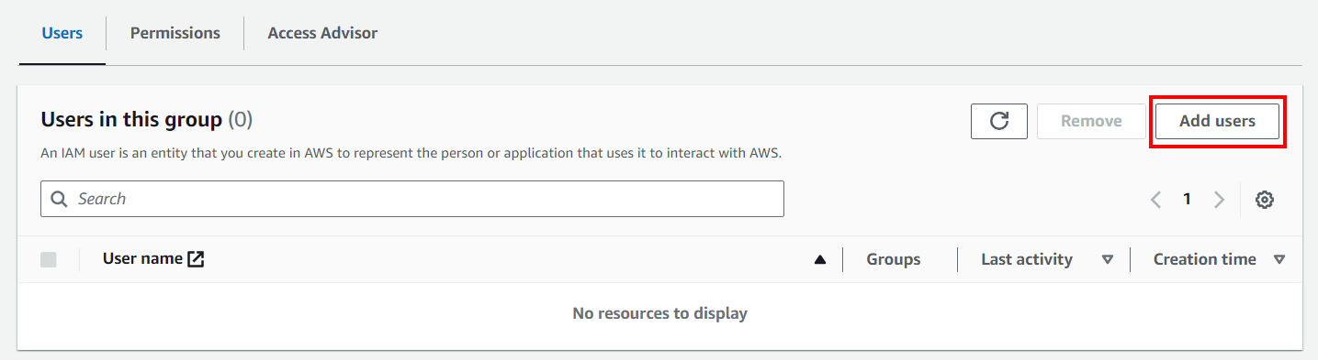

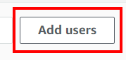

The screen will list users to add to the group. Check user-1 and press Add Users.

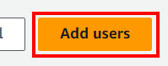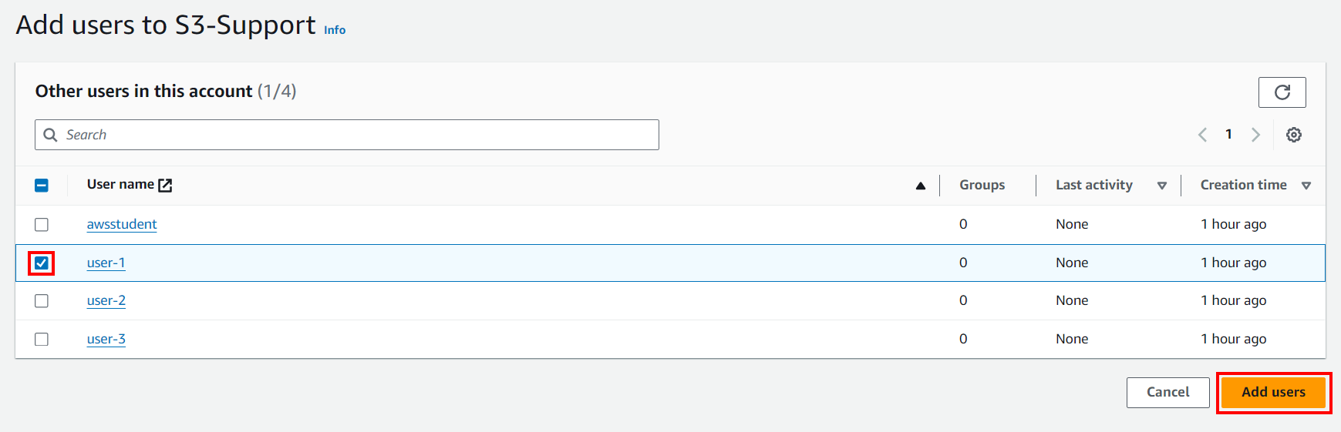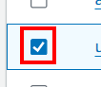

This notification should pop up under the search bar.

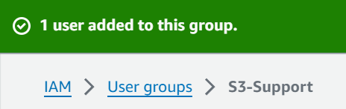

We can now see user-1 in the User tab in the S3-Support group.

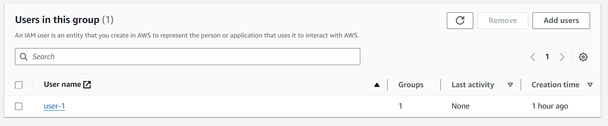

Repeat these steps for user-2 with EC2-Support and user-3 with EC2-Admin.

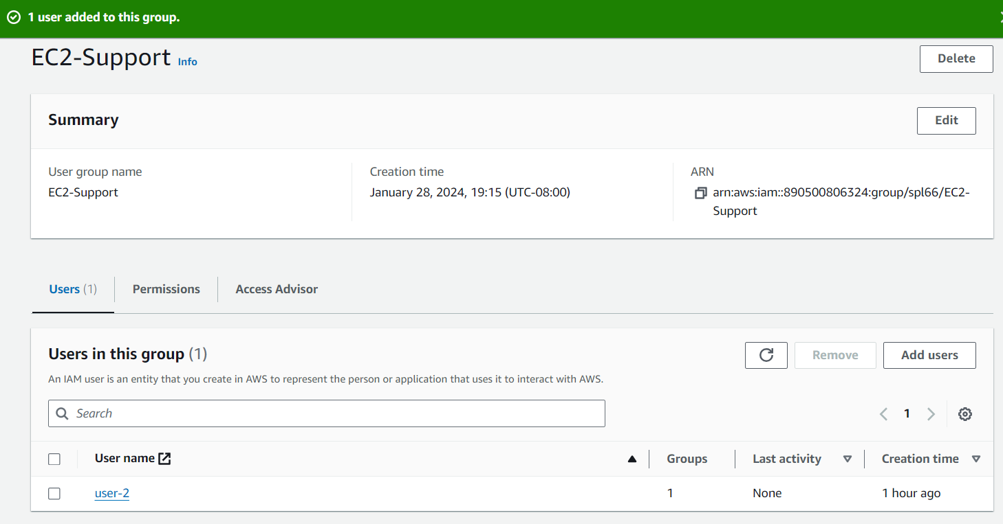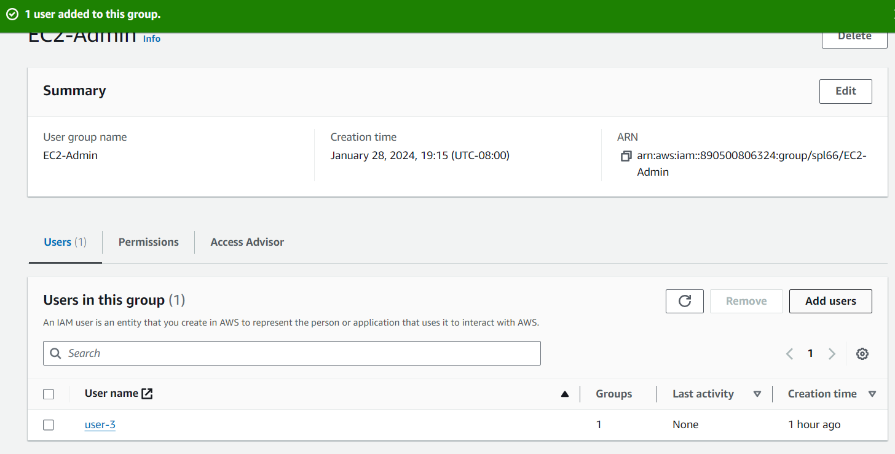

The groups now each show one user in each.

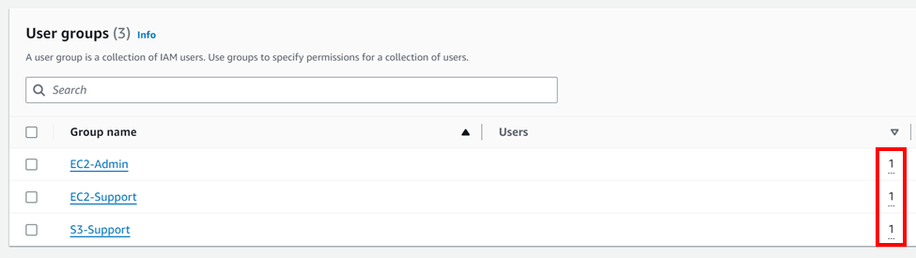

Now we can sign in as these users and see the policies applied in action.

Return to the dashboard.

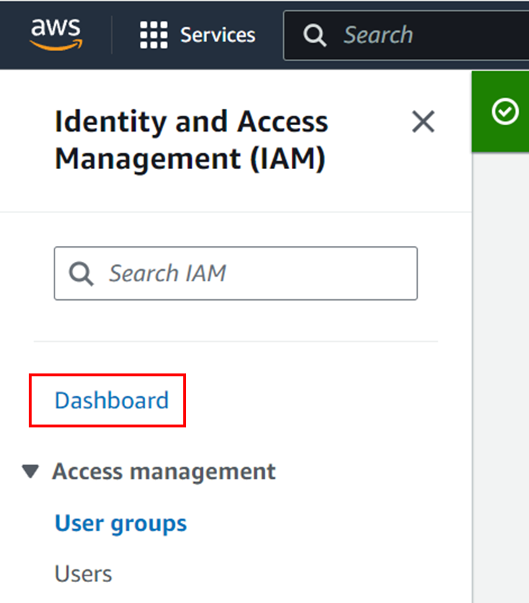

The link to sign in to the console for these users is displayed on the right of the IAM Resources panel.

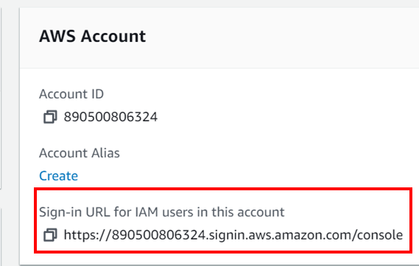

It appears to be discerned by the account ID.

Copy the sign in URL with the copy button.

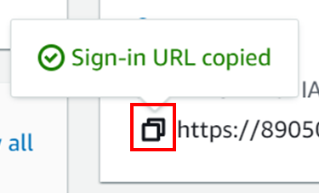

Open an **incognito** window and paste the link.

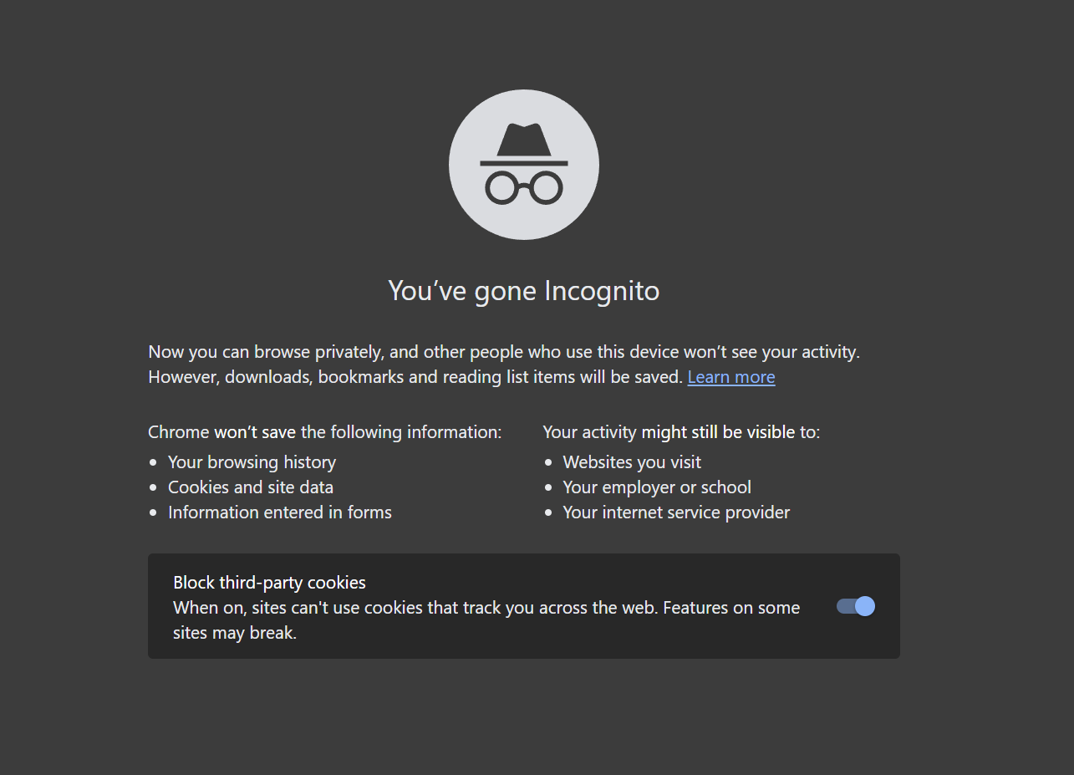

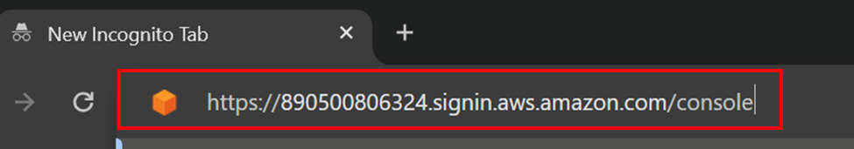

You will be redirected to a website that looks like this:

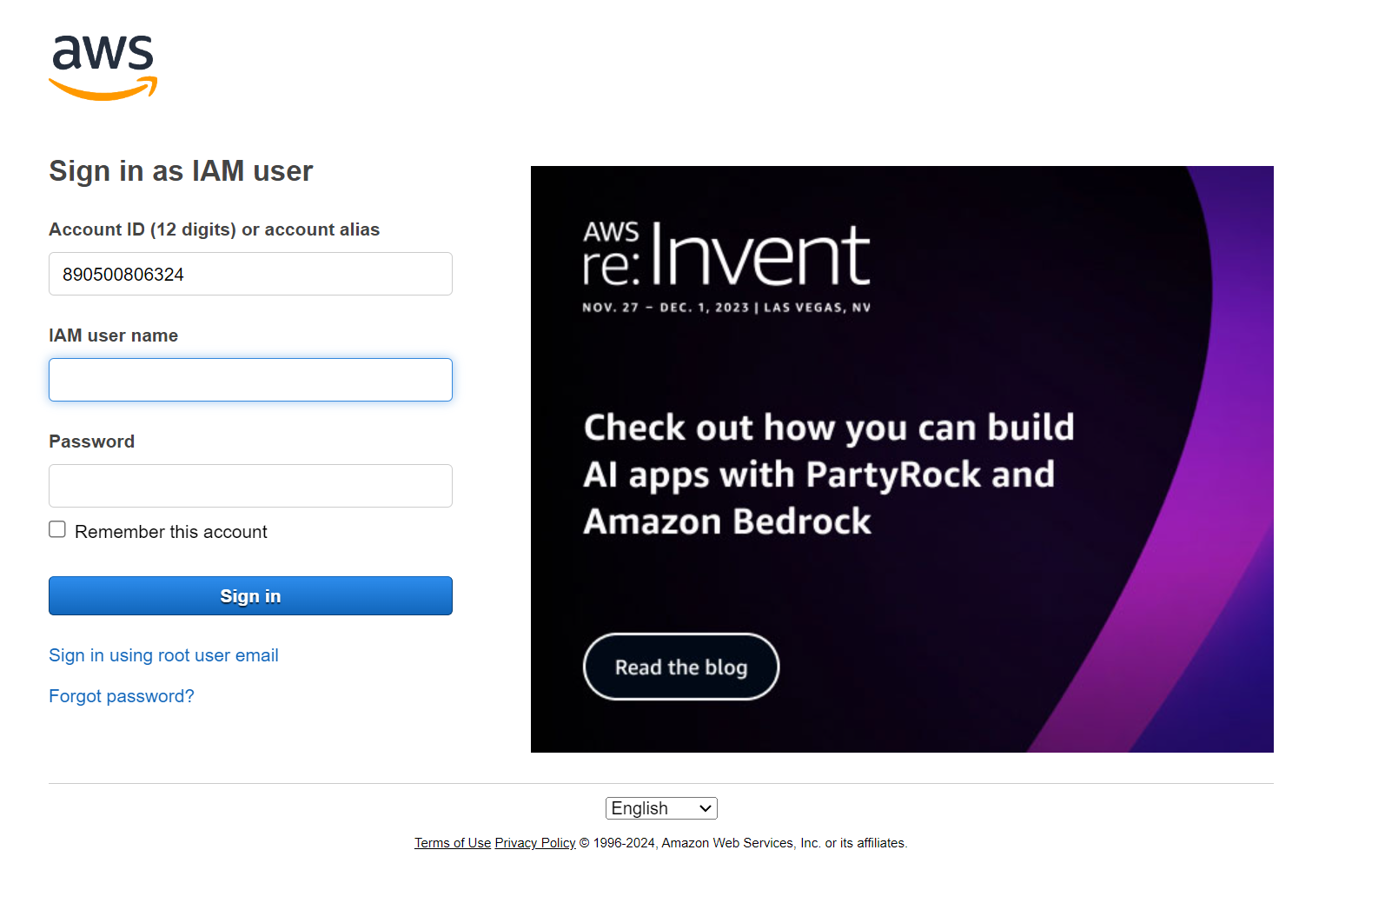

The users are configured with the passwords “Lab-Password<user #>”. Sign in with credentials.

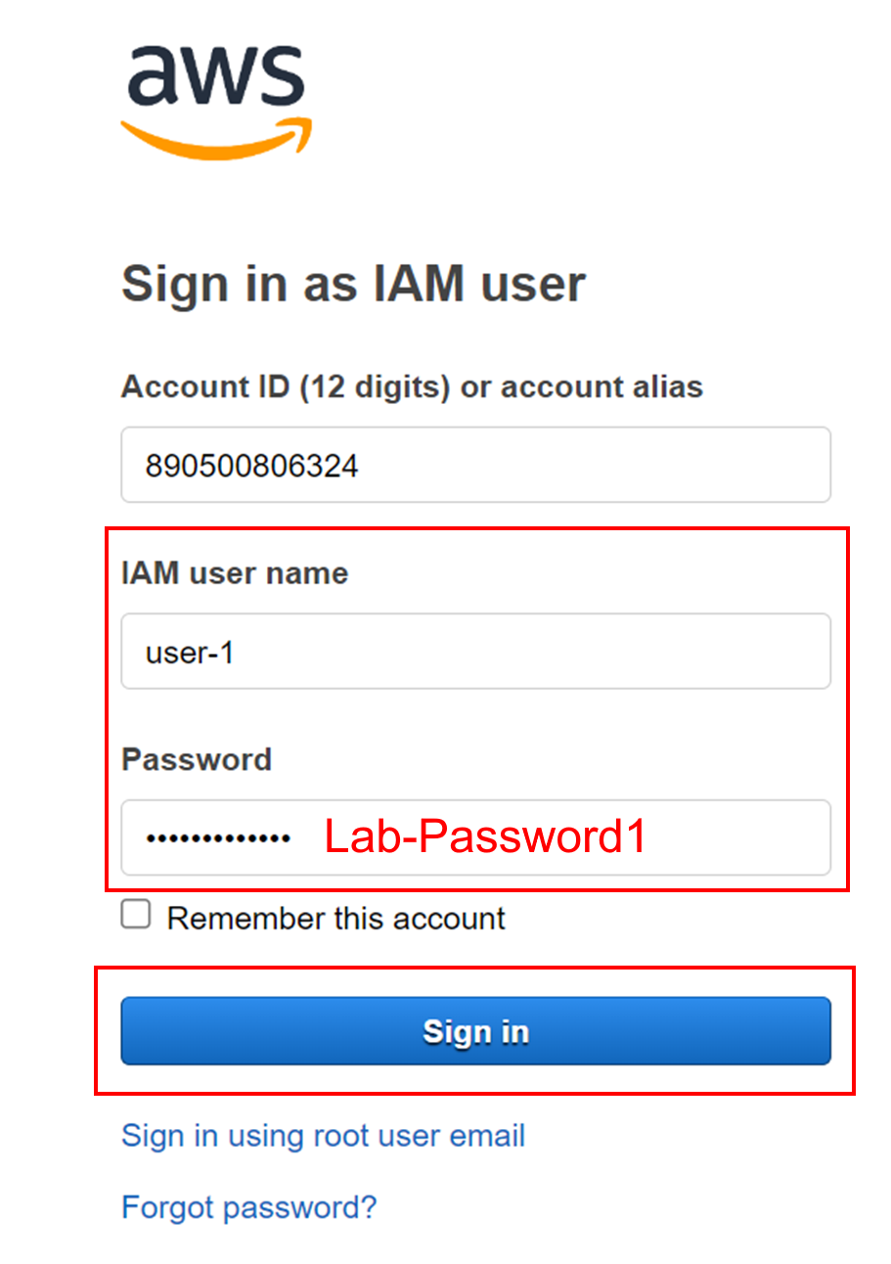

You will be logged into the console as user-1. From this console, select S3.

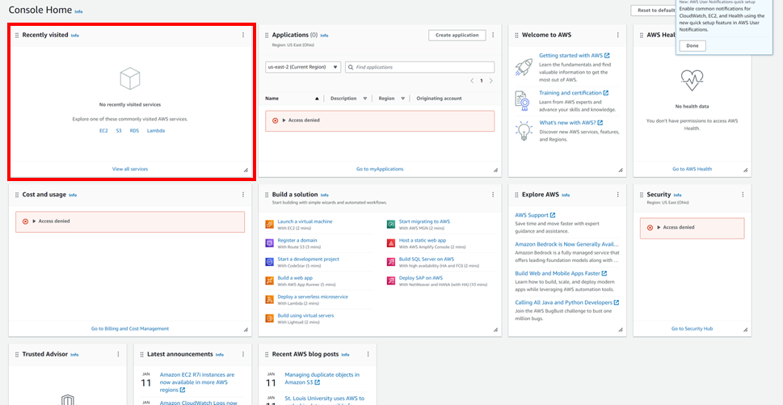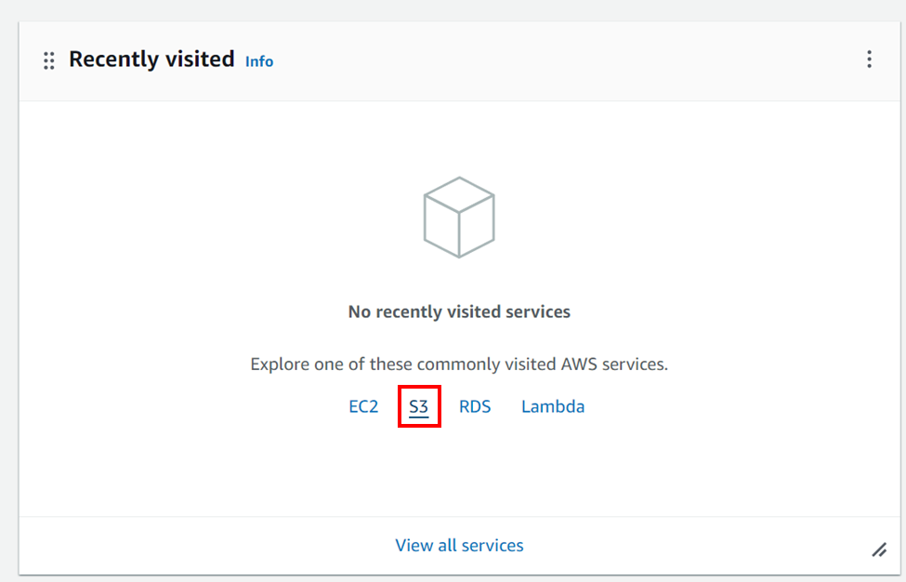

By the way, S3 stands for Simple Storage Service and is AWS’s object storage service.

We will be sent to the AWS S3 dashboard, were there is a bucket, or container, present. Click the bucket.

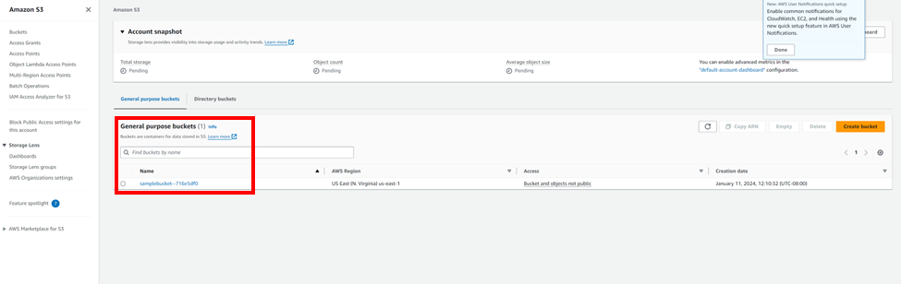

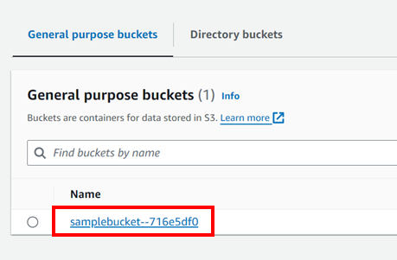

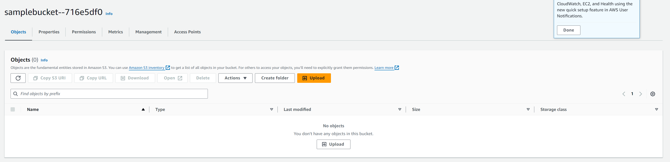

The bucket is viewable.

Navigate to EC2 from Services like earlier:

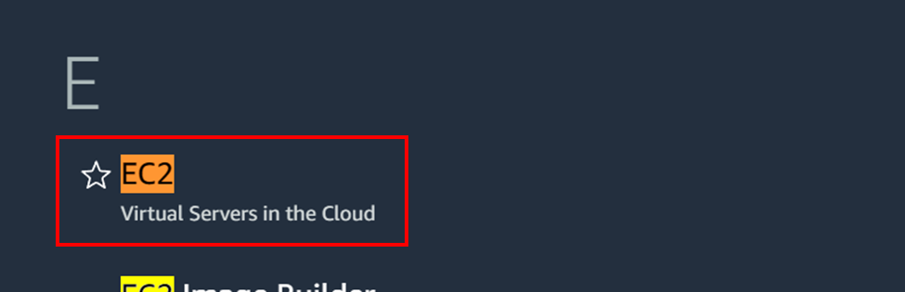

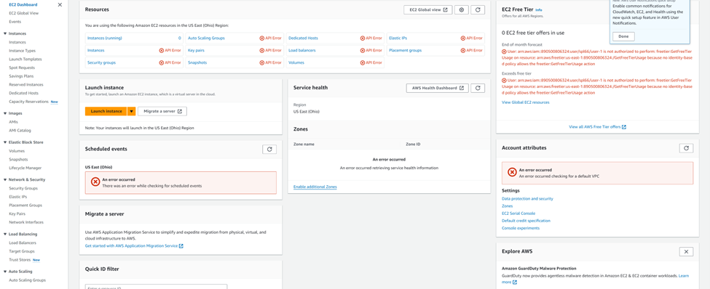

Already, we can see a lot of red and errors being shown. This is because user-1 does not have access to any EC2 permissions and cannot view any EC2 related things.

Navigate to the top right and sign out, then reopen the sign-in URL from earlier, and repeat the process for user-2 and user-3.

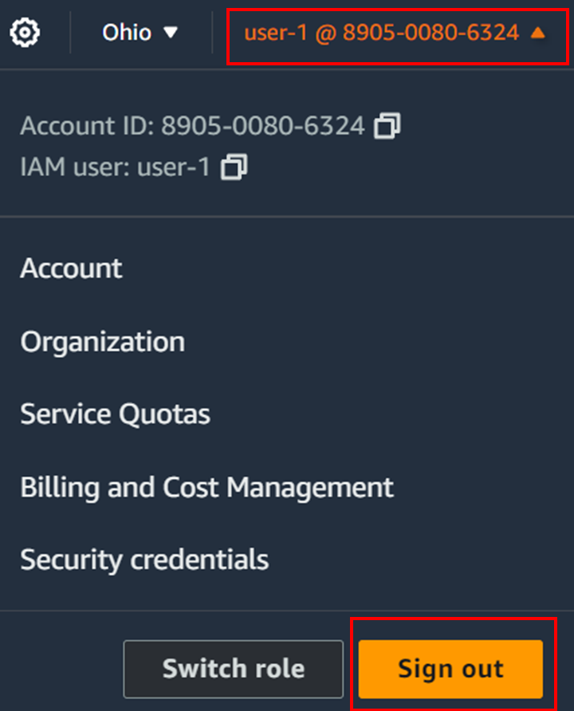

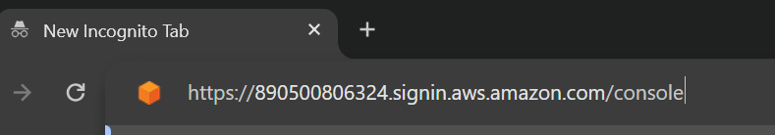

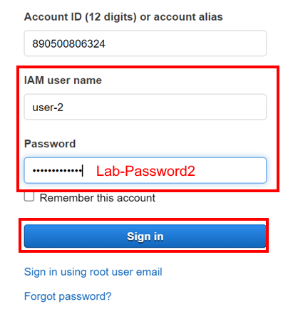

Navigate to S3 and select Buckets.

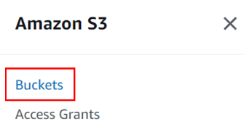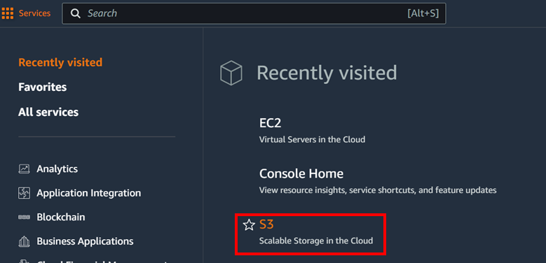

Like user-1 with EC2, user-2 does not have access to S3 because it lacks permissions from its group’s policy.

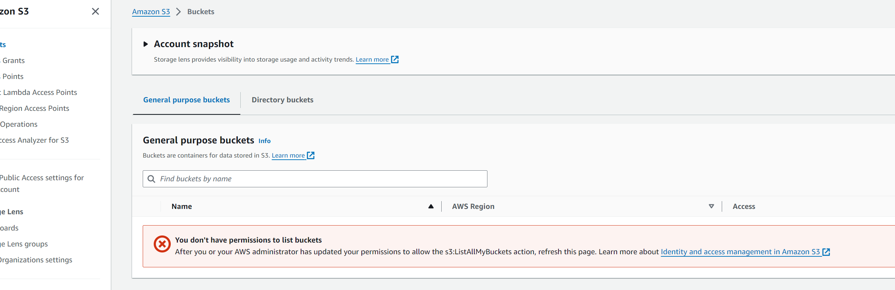

But, when we go to EC2, we can see that user-2 has less of the error messages in user-1, since user-2 has access to the ec2:Describe permission.

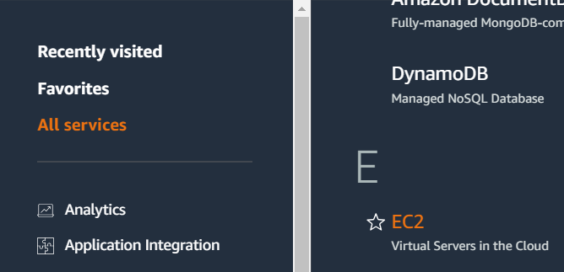

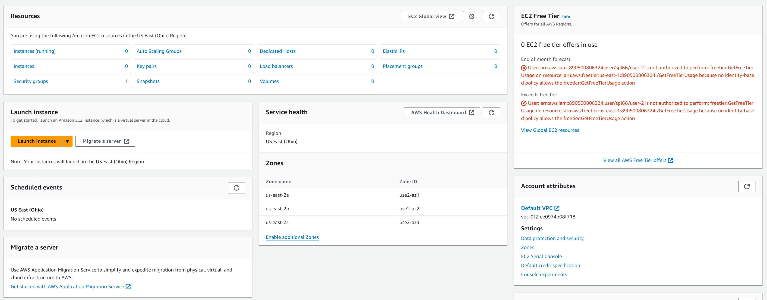

If we switch to the Instances tab from the left sidebar, we should either see one of two results:

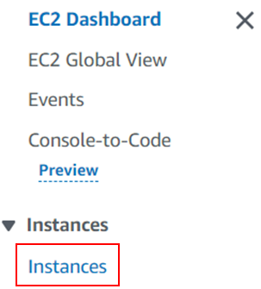

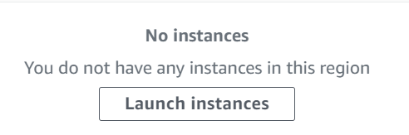 OR 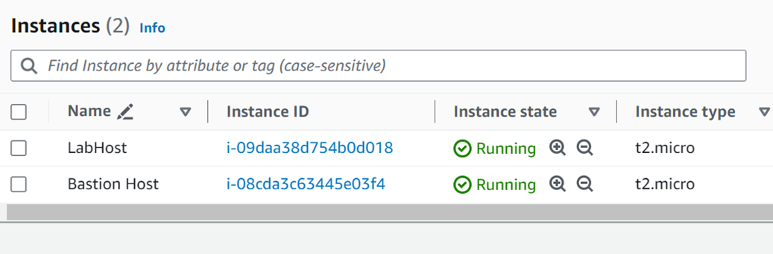

If the console says there are no instances, this is because the region with the instances is not configured. Focus to the top right of the page and change the region to N. Virginia.

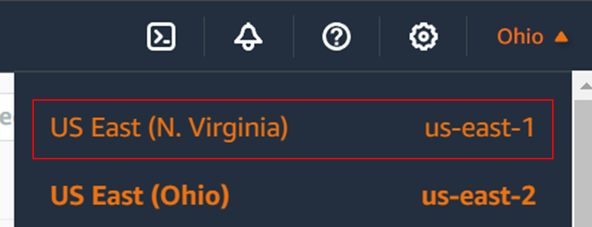

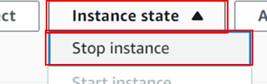The instance should show up. Select the LabHost instance, open the Instance state menu at the top right of the panel and select “Stop Instance”, and click the “Stop” button.

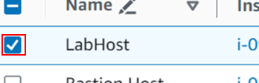

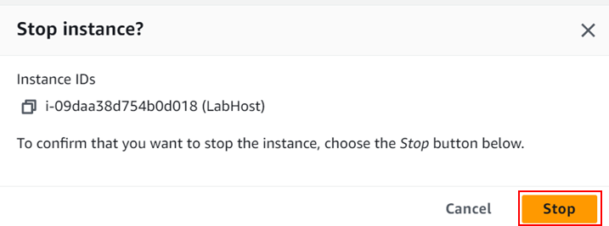

The action should fail, and a popup should appear. This is because user-2 does not have access to the EC2 permissions needed to stop an instance.

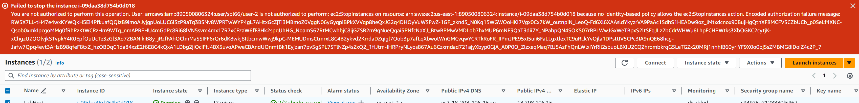

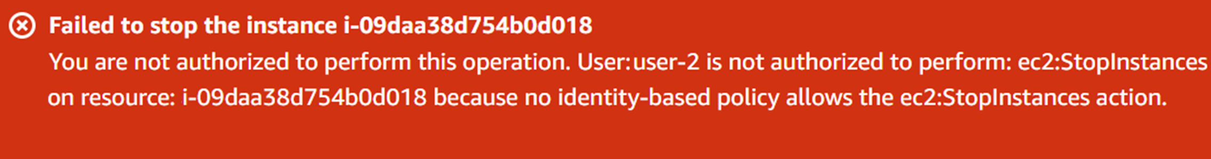(This image is edited for visual purposes)

Now for user-3, sign out of user-2 and sign back in as user-3.

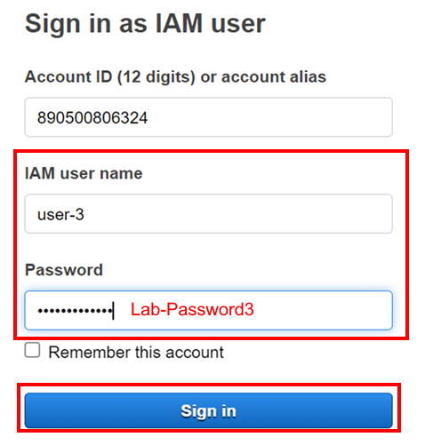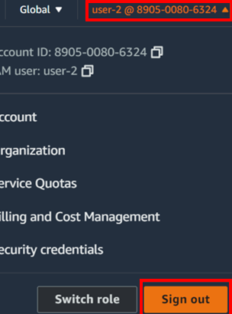

The S3 will show the same as user-2 since user-3 also does not have permissions for S3, so there is no need to show the S3 console.

Go to EC2, select Instances, and try to stop the LabHost instance as done earlier.

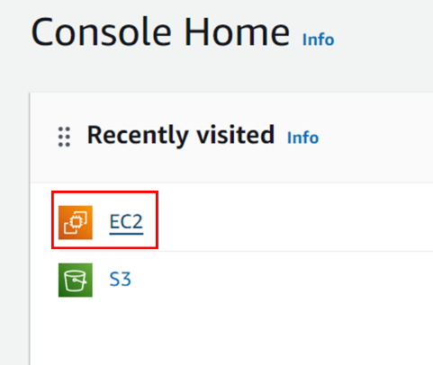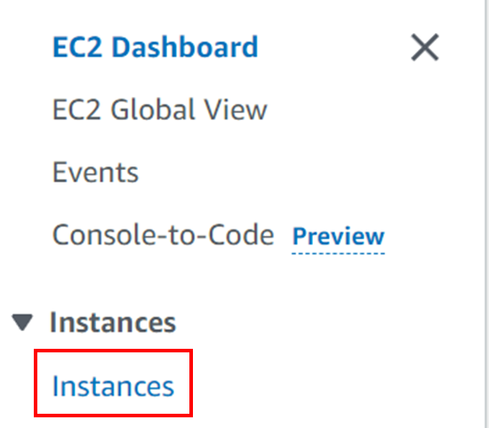

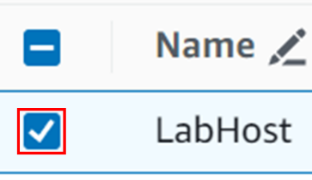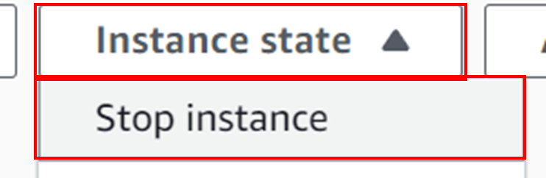

This time, the instance will stop successfully, and the instance state will eventually switch to “Stopped”.

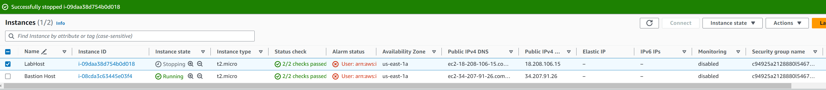

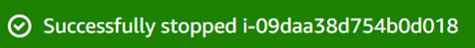

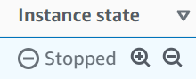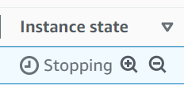

As we can see, user-3 has more permissions in EC2 than user-2 since its policy gives it more power.

Lab 2 – Build Your VPC and Launch a Web Server

# Purpose

The purpose of this lab is to introduce AWS’s Virtual Private Cloud (VPC) by making a VPC in the AWS console and configuring it to create a network and integrate EC2 into the VPC.

# Background Information

AWS VPC is a cloud computing service by Amazon to launch AWS resources in an isolated, virtual network. It contains subnets and security groups, in which communicate with different AWS applications such as EC2. These other resources can do many things from setting security measures to prevent unwanted attackers gaining information to being able to have a highly customizable networking system that can direct internet traffic to many areas as needed. VPC can also support multiple availability zones (AZ), so it can be easily accessed without location being a bottleneck to efficiency.

# Lab Summary

In this lab we create a VPC configured with public and private subnets, then create security groups to allow HTTP traffic through so the VPC can be accessed from online, and finally attach an EC2 instance to the VPC and test the web page created from the configuration.

# Configurations

Start the lab and open the AWS console, then search for VPC in the search bar and open up the VPC console.

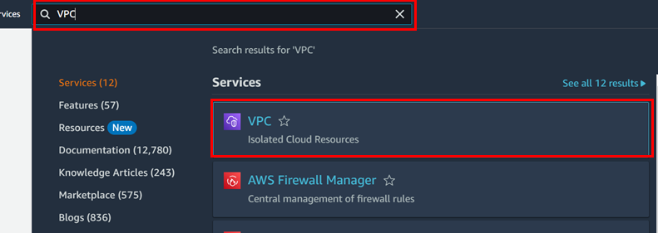

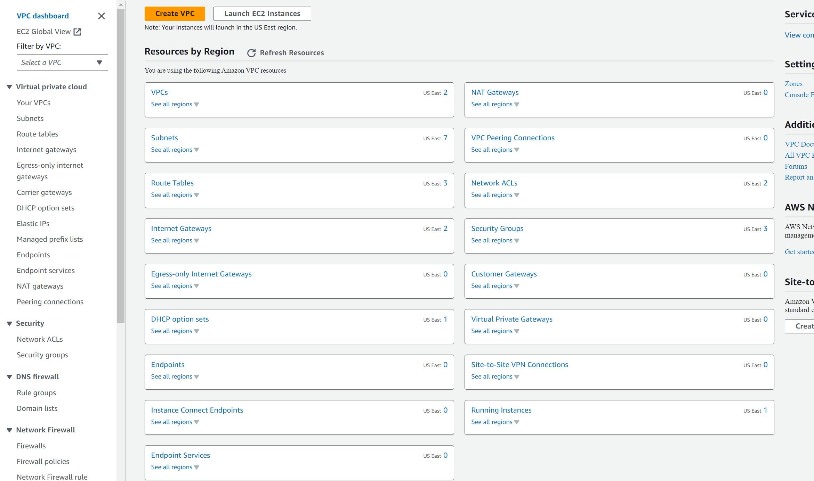

This page should be displayed

If not already, change the region to us-east-1, or N. Virginia.

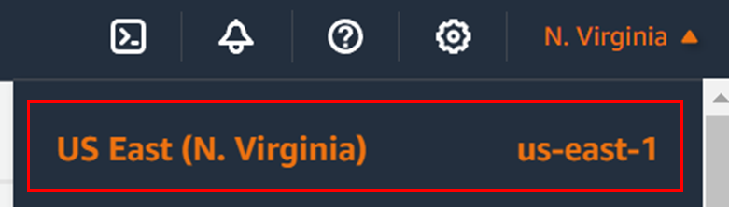

Press the “Create VPC” button under the search bar to configure a new VPC.

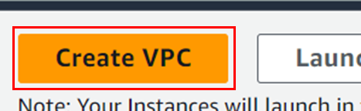

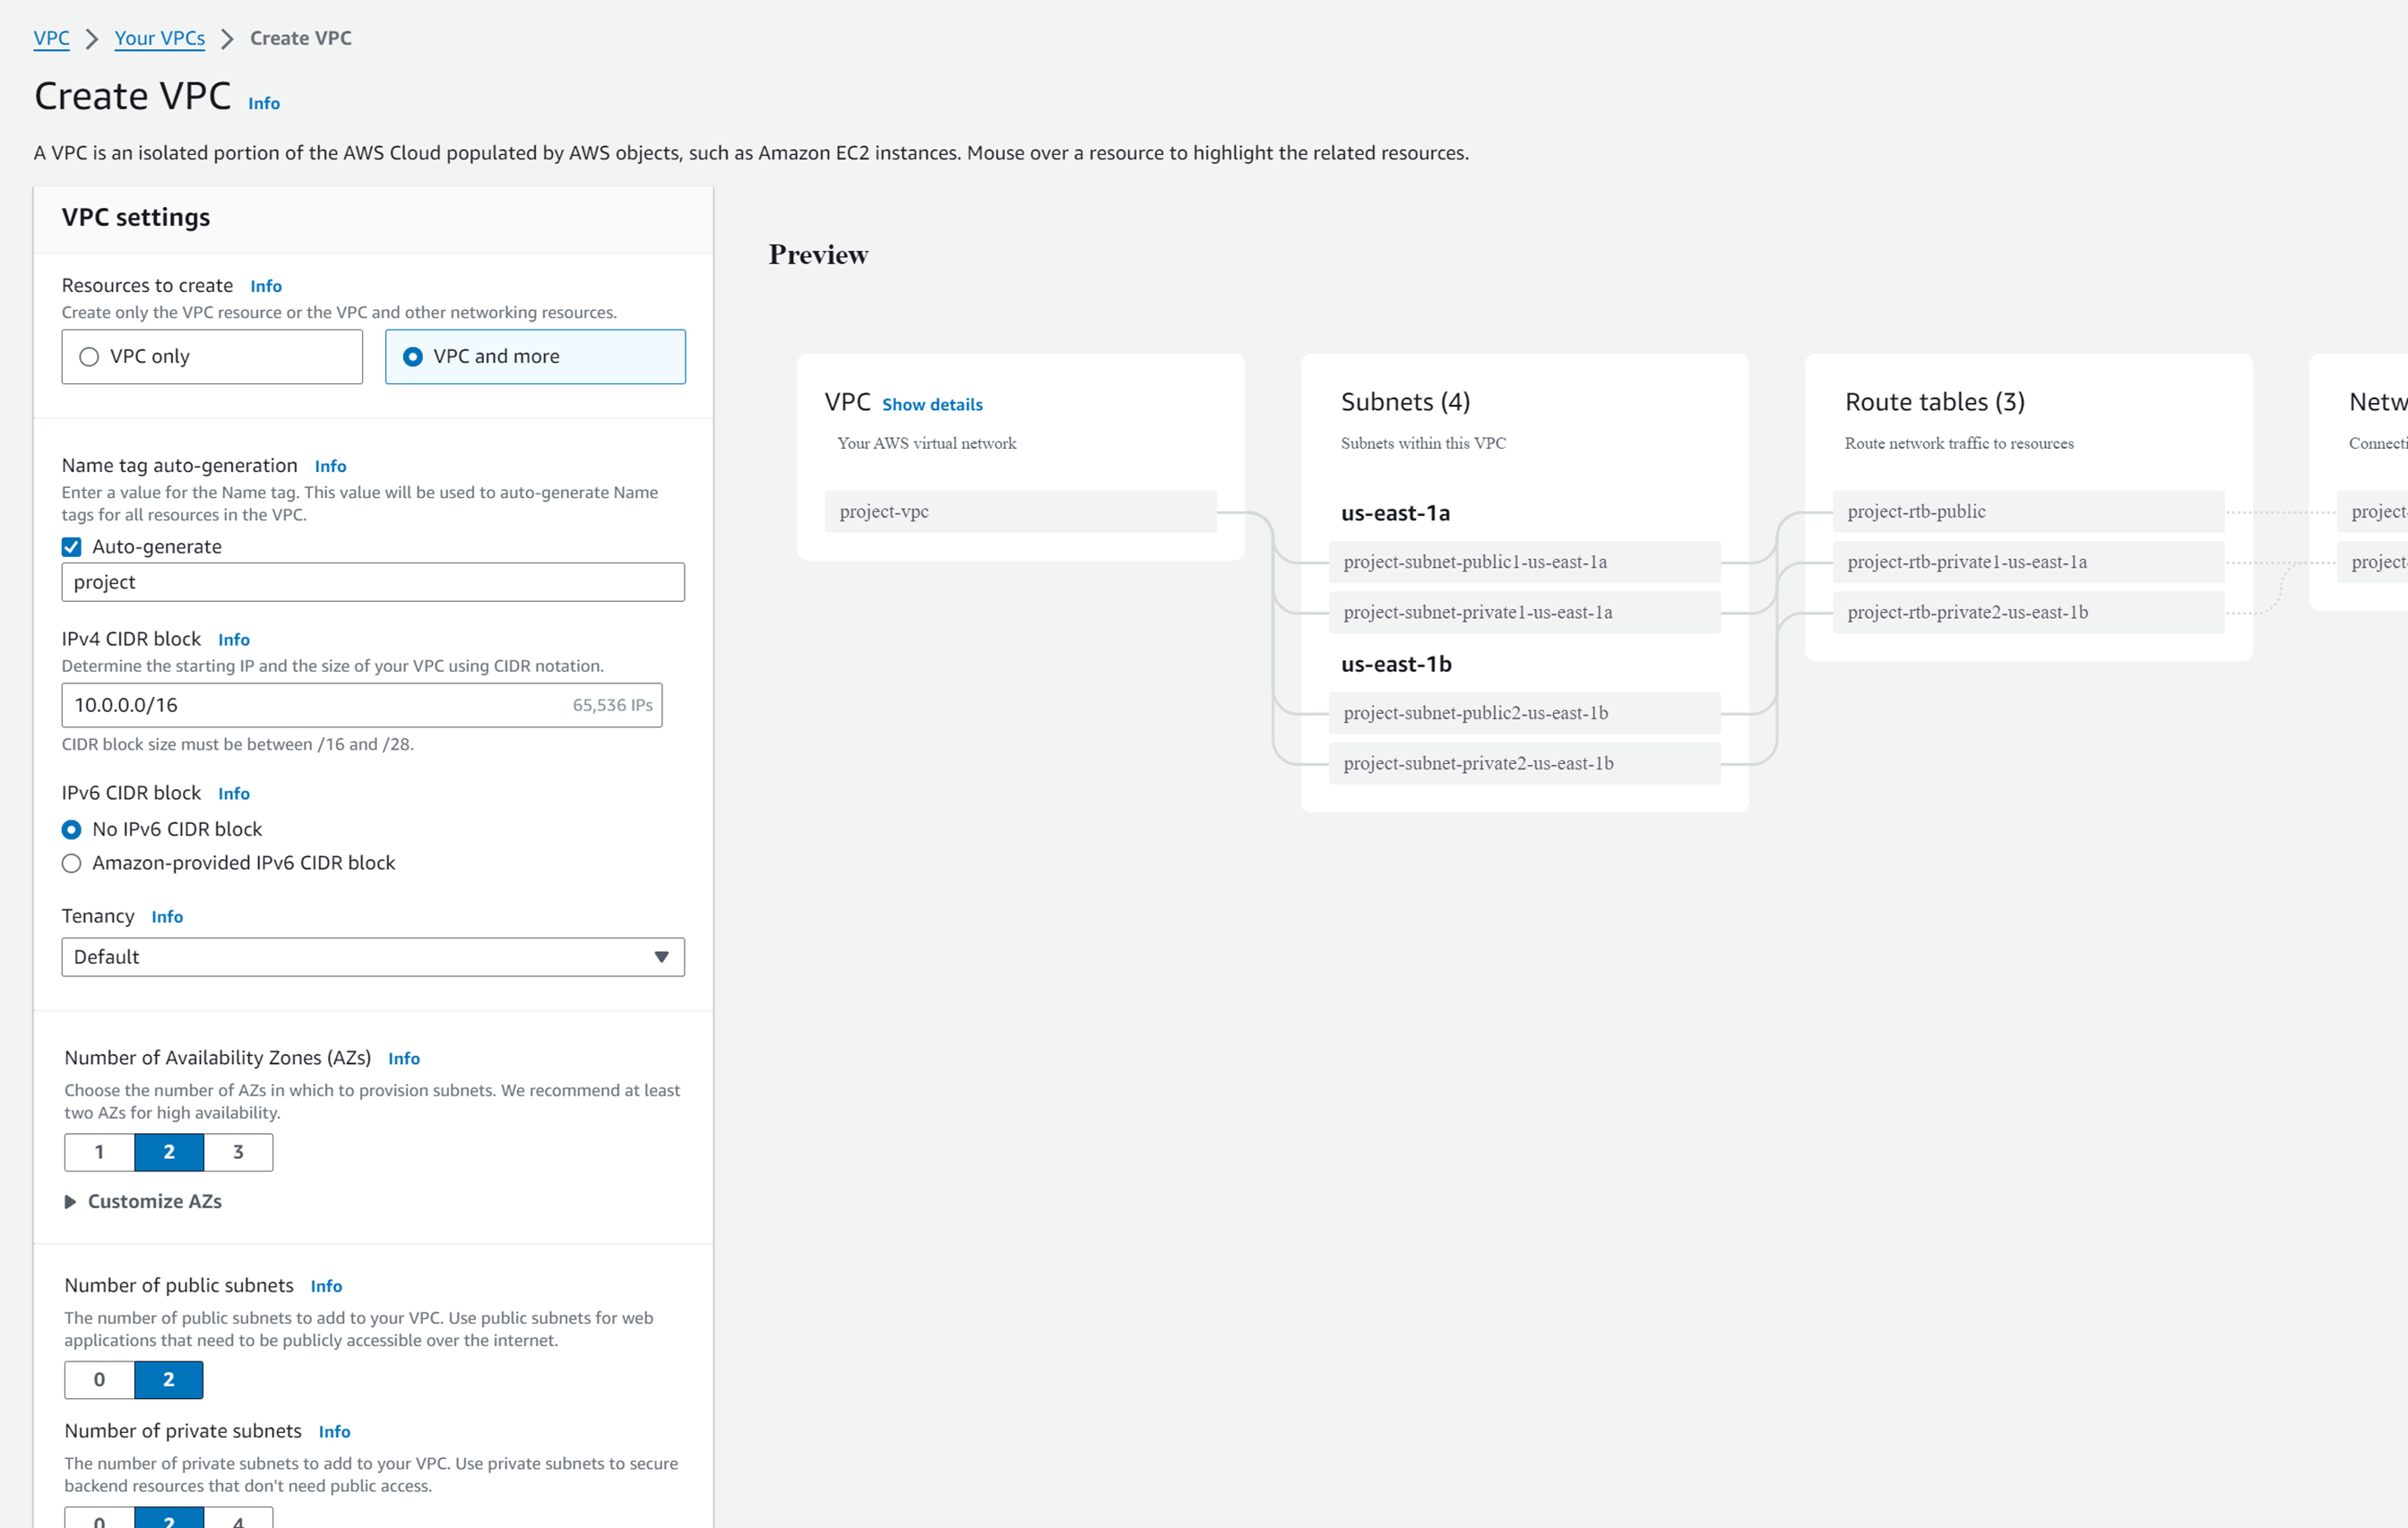

This page should be displayed. On the left is the configuration options for the new VPC being made, and on the right is a visualization of the VPC.

Configure the VPC with the following:

* Set resources to create to “VPC and more”. This will create a VPC but also create other networking resources such as subnets and VPC endpoints.
* Set the name tag to lab. This configures the first part of the VPC and related resources naming scheme.
* Configure the IPv4 CIDR block to 10.0.0.0/16. This specifies the IPv4 Ips for the VPC in a CIDR format (<address X.X.X.X>/<subnet X>)
* Change the number of availability zones to 1. This will configure the availability zones the VPC’s will make subnets for.
* Keep both public and private subnets at 1
* Expand the “Customize subnet CIDR blocks” and change the CIDR blocks so they are 256 IPs each – The public subnet should be 10.0.0.0/24 and the private subnet should be 10.0.1.0/24.
* Change the NAT Gateways so there is one in a single AZ. This is important for resources launched in private subnets to be able to connect to services outside the VPC.
* Set VPC Endpoints to none. VPC Endpoints are used to reduce costs from NAT Gateways and improve security by making S3 accessed directly from the VPC.
* Keep DNS options selected

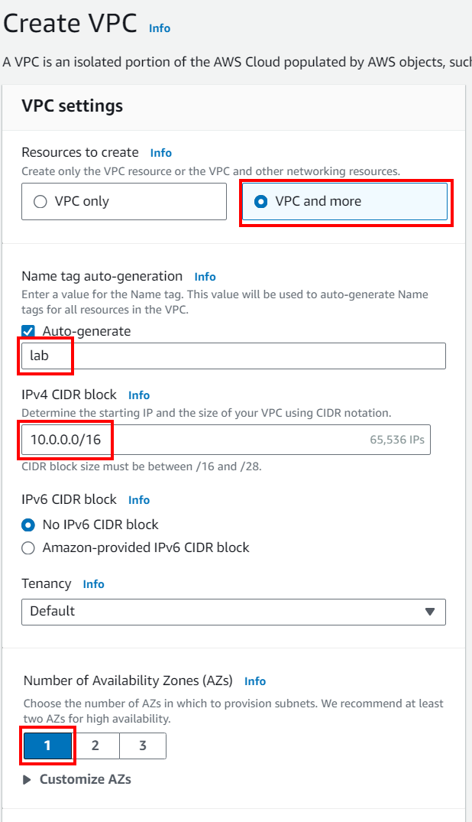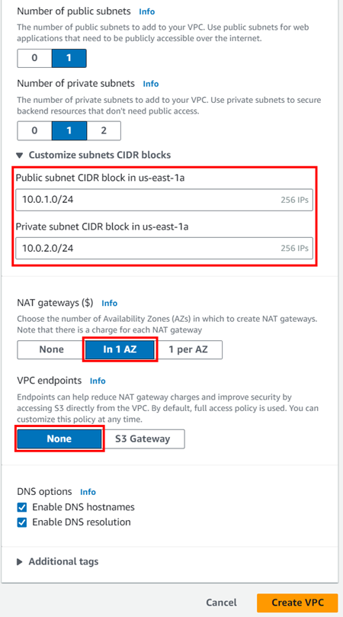

Check settings are correct by looking at the preview. We can see everything has the prefix “lab”, there is one AZ with one public and one private subnet, and that there is a NAT Gateway in the Network Connections portion, all as configured. After making sure the settings are correct, press “Create VPC”.

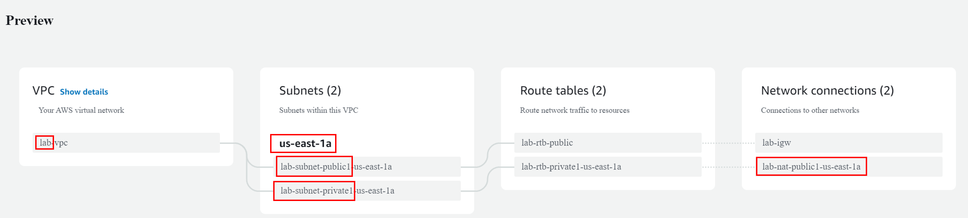

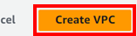

The VPC will begin creation.

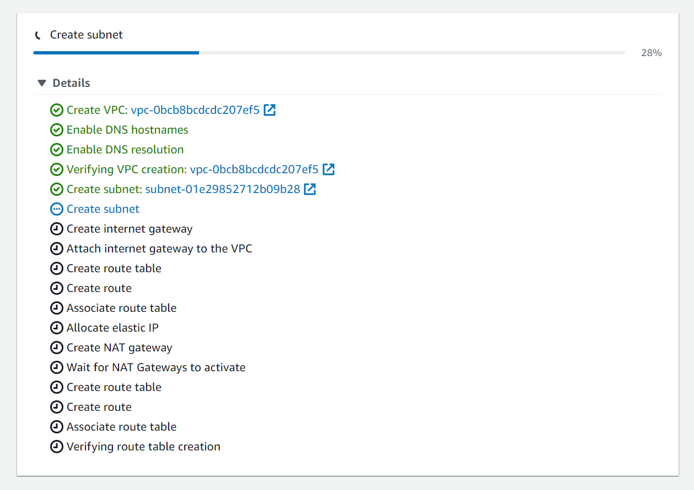

When the creation of the VPC is finished, press View VPC.

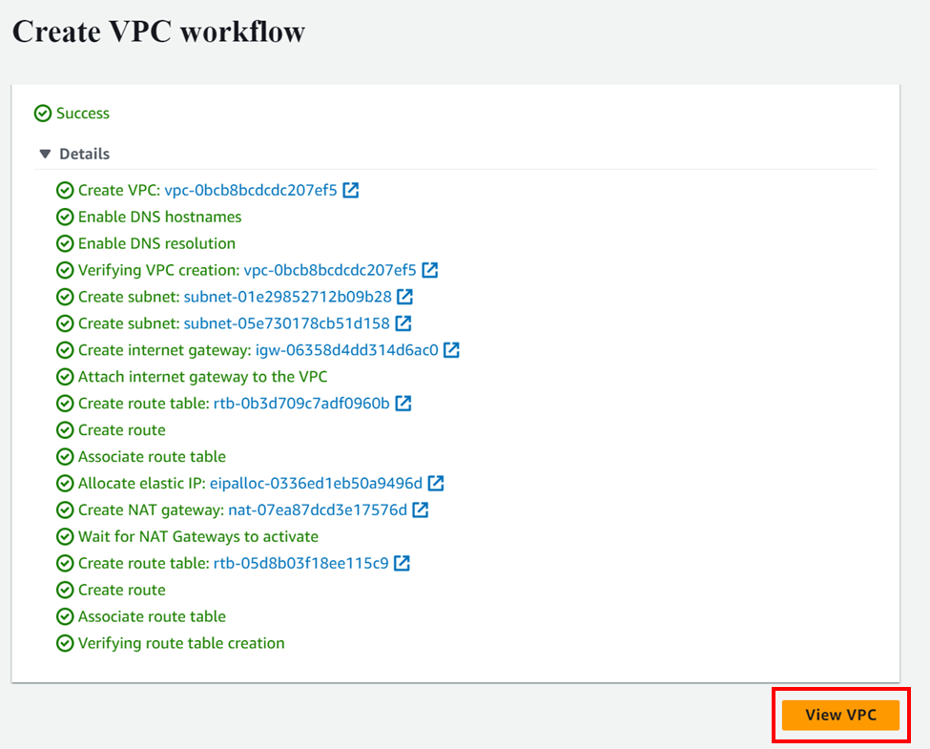

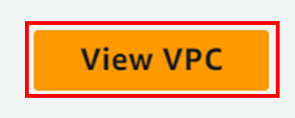

We will be redirected to the VPC’s page with details and a group of tabs with more information about the VPC.

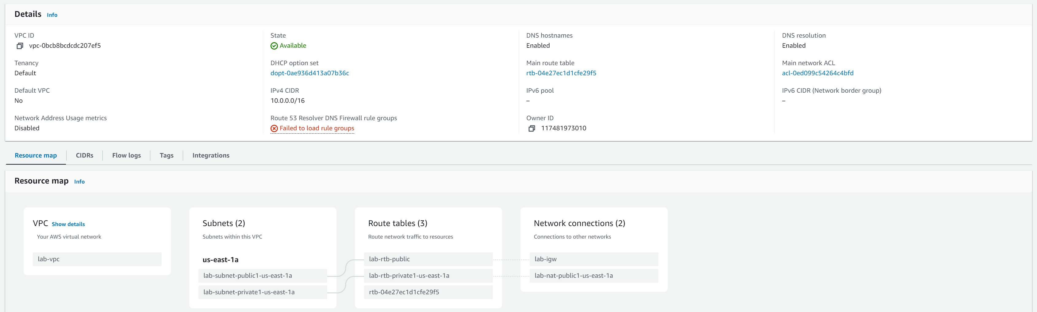

Looking at the resource map, details can be retrieved on the different resources in the VPC by hovering over the desired resource and pressing the  button.

Next, we will create another availability zone and another public and private subnet for this VPC. On the left sidebar, navigate to Subnets.

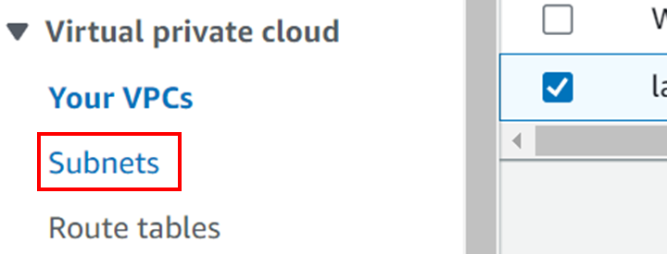

There is a table of created subnets in all of the VPCs, and at the bottom we can see the subnets that were just created. To create a new subnet, press the “Create Subnet” button at the top right corner of the panel.

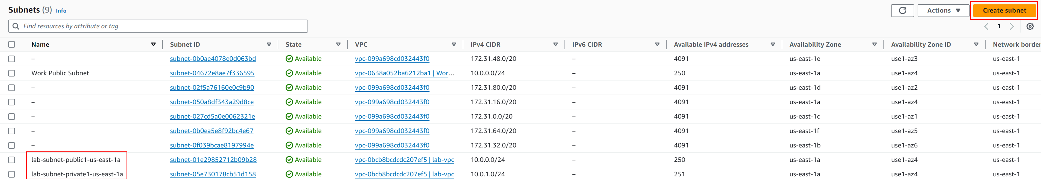

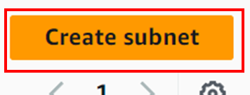

This page will come up. We will configure the VPC the subnet applies to.

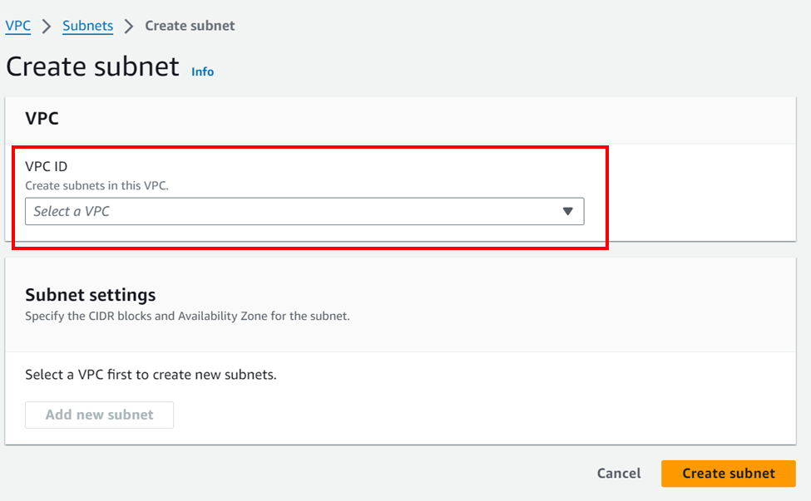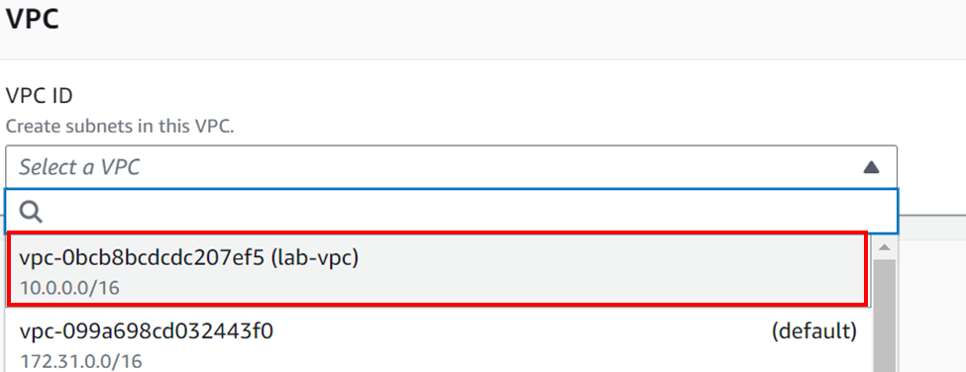

After configuring the VPC, the subnet settings will be displayed.

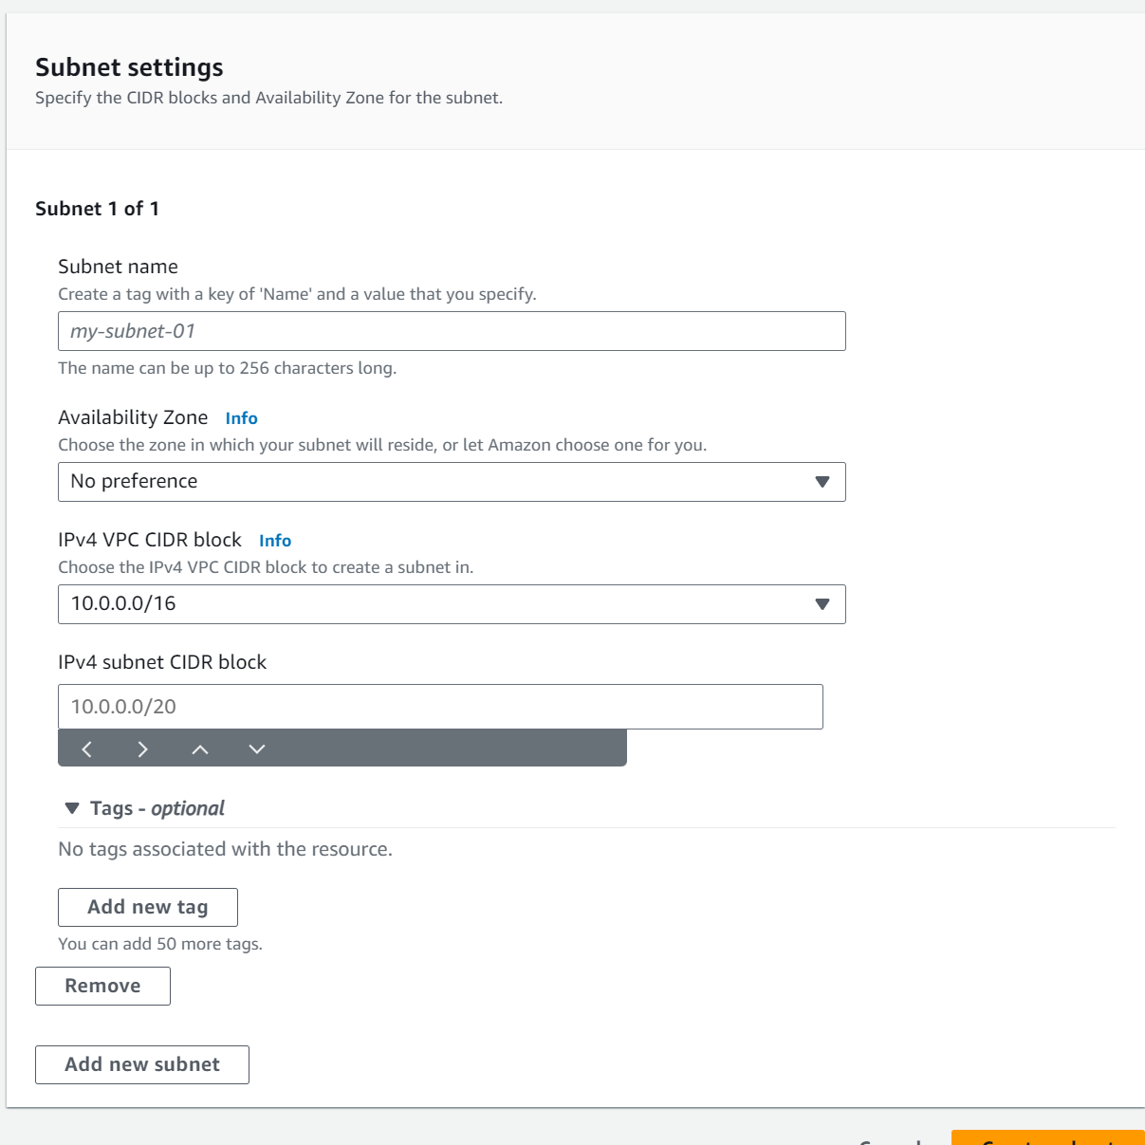

Configure the subnet with name lab-subnet-public-2, in availibility zone us-east-1b, and an IPv4 CIDR block 1.0.2.0/24.

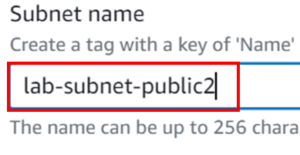

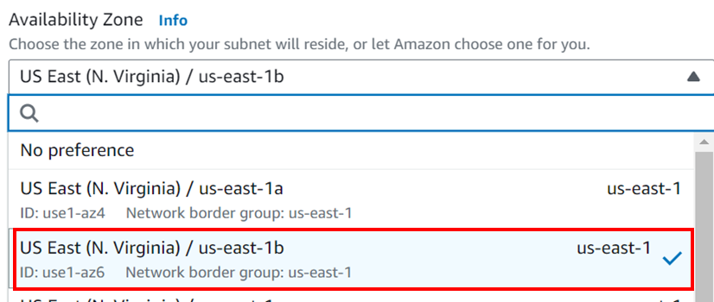

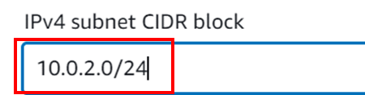

Scroll down and press the “Create Subnet” button.

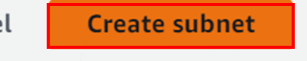

Repeat the steps with another subnet named lab-subnet-private2 in the same AZ and a IPv4 subnet CIDR block of 10.0.3.0/24.

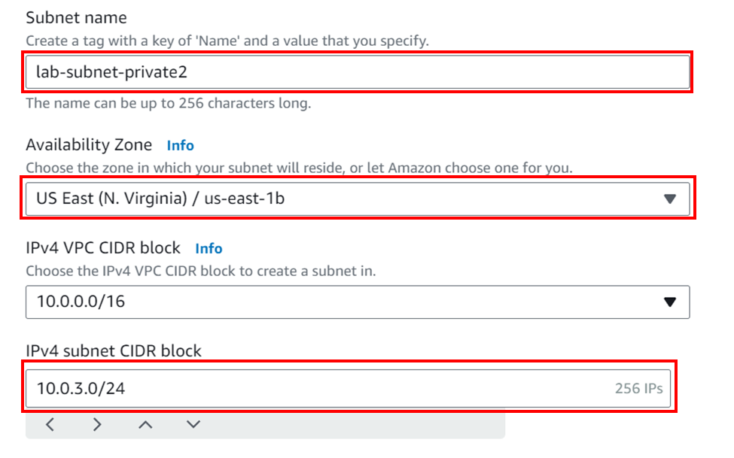

The subnets have now been created. They should show up on the subnet table.



Now that the subnets have been created, we need to associate them to the route table so the private subnet routes traffic to the NAT Gateway. On the left sidebar, navigate to Route tables.

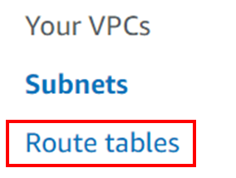

Similar to subnets, the route tables will be displayed in a table.

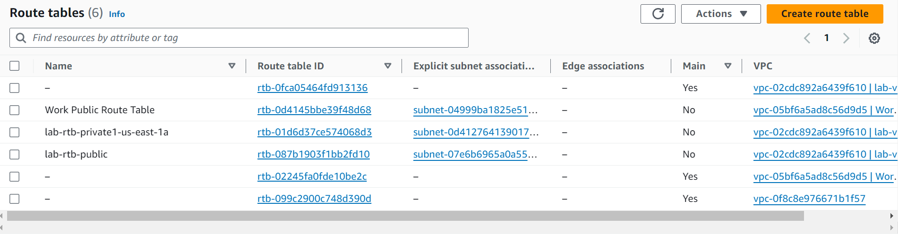

Here, select the lab-rtb-private1-us-east-1a route table.

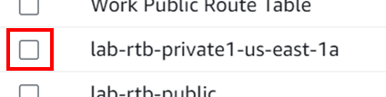

There is a pane under the table that will be filled with the information on the lab-rtb-private1-us-east-1a route table after selecting.

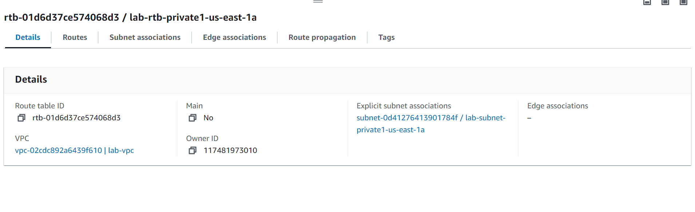

Navigate to the Routes tab.

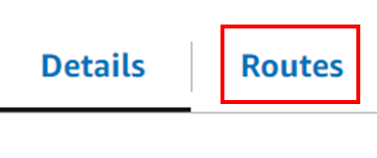

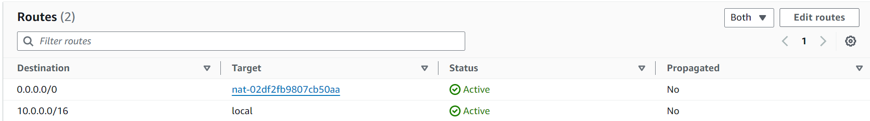

Traffic to 0.0.0.0/0 (all traffic) is directed to the NAT Gateway. This is how we know this is the route table we want to modify.

Navigate to the Subnets tab.

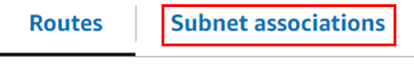

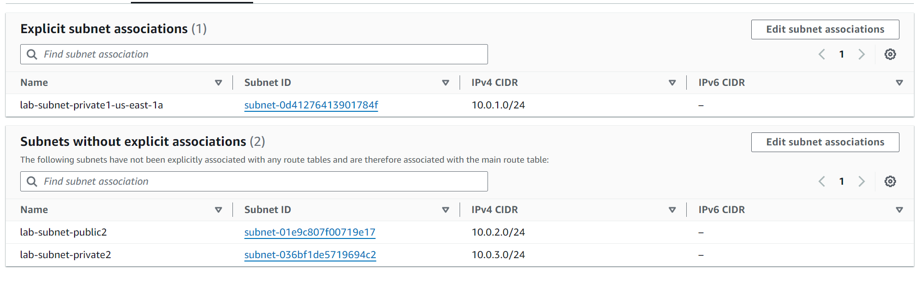

Here we see the subnets associated with this route table in the Explicit subnet associations panel, along with the subnets which have not been associated with any route tables in the Subnets without explicit associations panel. We want to add lab-subnet-private2 to to this route table. So, focus on the Explicit subnet associatiations panel and press the “Edit subnet associations” button on the top right of the panel.

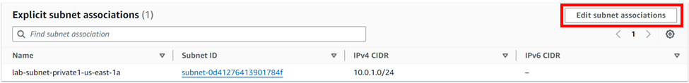

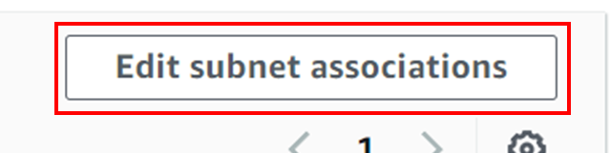

A table will pop up with the current subnets associated with this route table already selected.

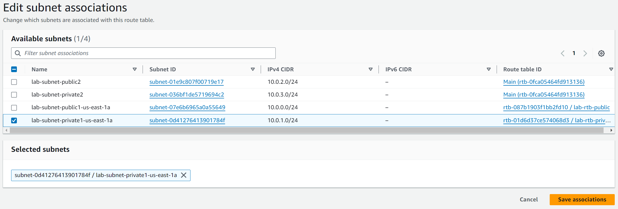

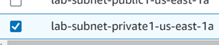

Select the subnet lab-subnet-private2.

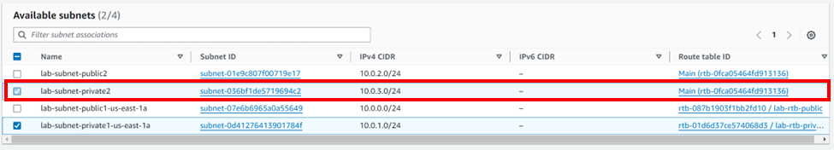

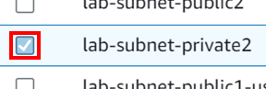

Press the “Save associations” button to save changes.

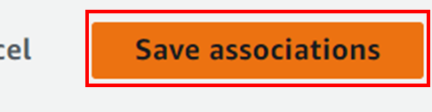

Now the lab-subnet-private2 subnet will be listed under the Explicit subnet associations table of this route table.

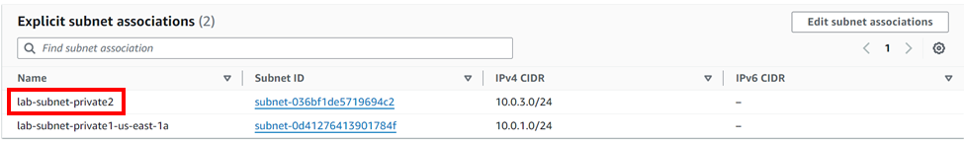

Repeat this process with the lab-rtb-public route table and the lab-subnet-public2 subnet.

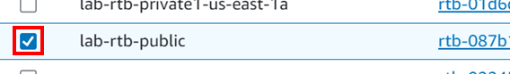

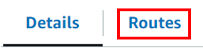

Note that the lab-rtb-public route table directs traffic to the Internet Gateway, meaning traffic will go directly to the internet.

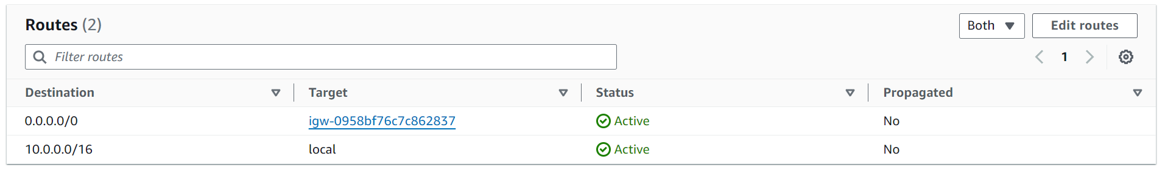

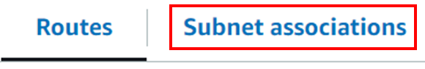

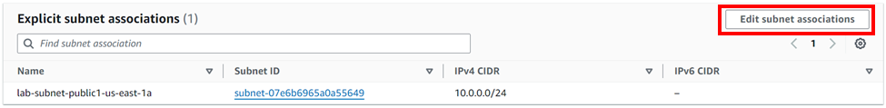

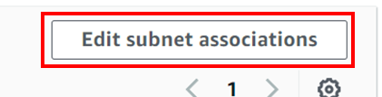



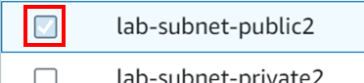

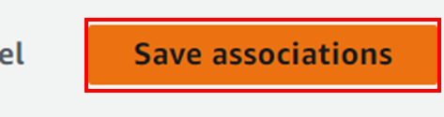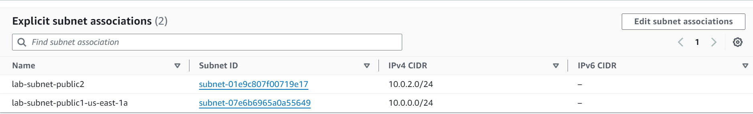

Now, both subnets that were created after VPC creation are associated with the proper route tables and should direct traffic properly.

If we go back to the VPC resource map, it will now show the two new subnets.

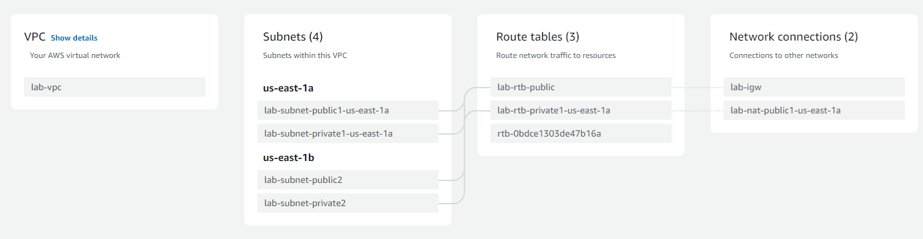

Now, we will create a security group, which acts as a virtual firewall for VPC, to allow HTTP traffic through.

From the left sidebar, navigate to Security groups.

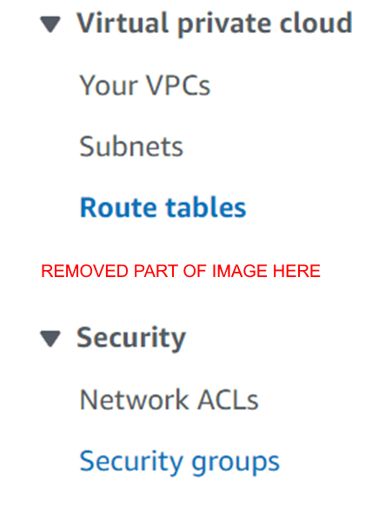

(This image has been shortened for visual purposes)

There will be a table listing security groups. Press the “Create security group” button at the top right of the panel to begin creation of a new security group.

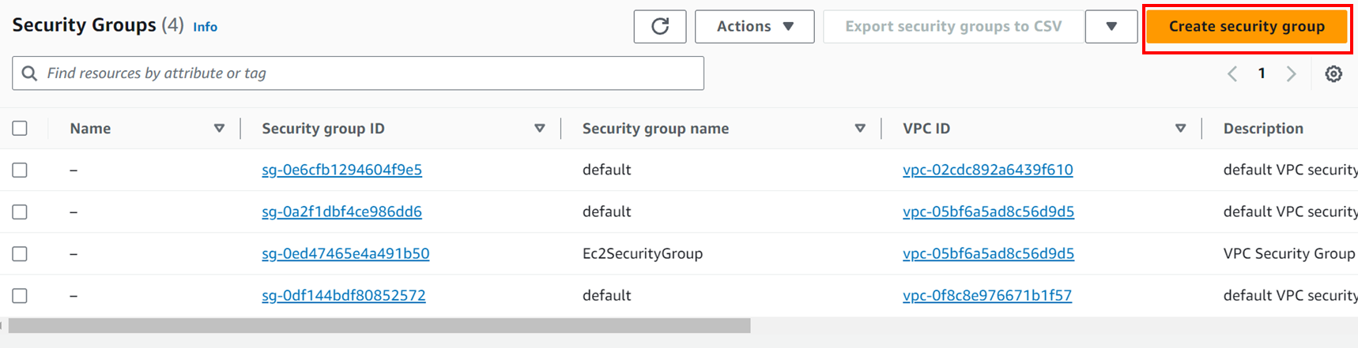

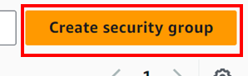

Fill out basic details with the name Web Security Group and description Enable HTTP access, and the VPC lab-vpc.

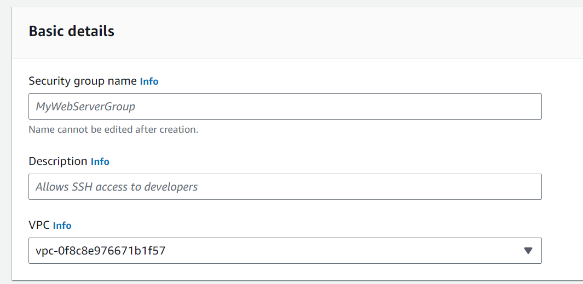

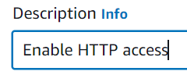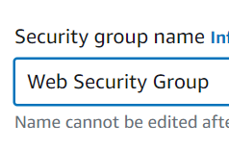

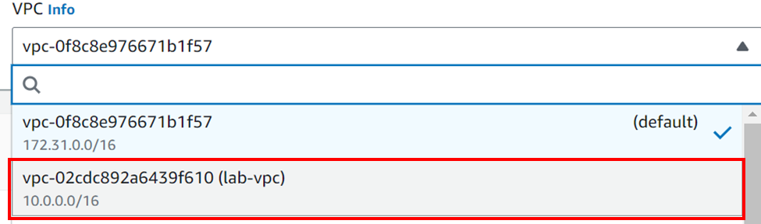

Next, create an inbound rule.

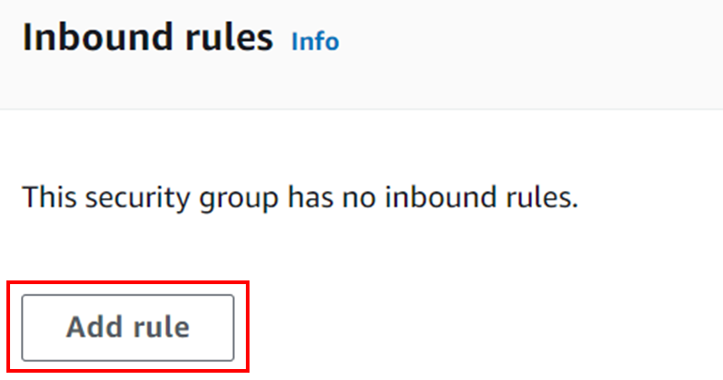

A blank rule will be made, and we will configure it to allow HTTP traffic to the VPC.

  
Expand the “Type” dropdown menu and search for HTTP, and select it.

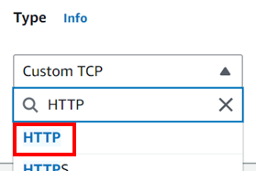

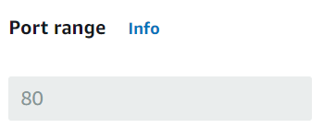

The port range will be grayed out and set to 80, as this is the TCP port for HTTP.

Change the source to Anywhere-IPv4. This will set the source to 0.0.0.0/0.

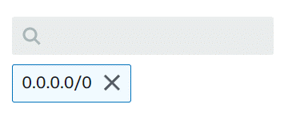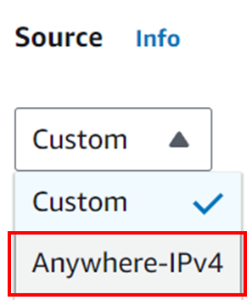

Set the description to Permit web requests.

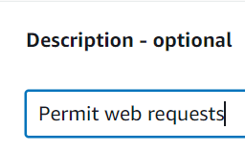

We have finished configuring the security group. Scroll down and press the “Create security group” button.

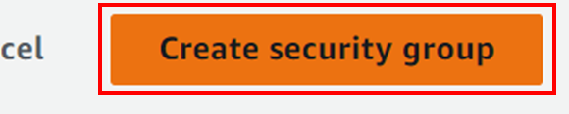

The security group has now been created.

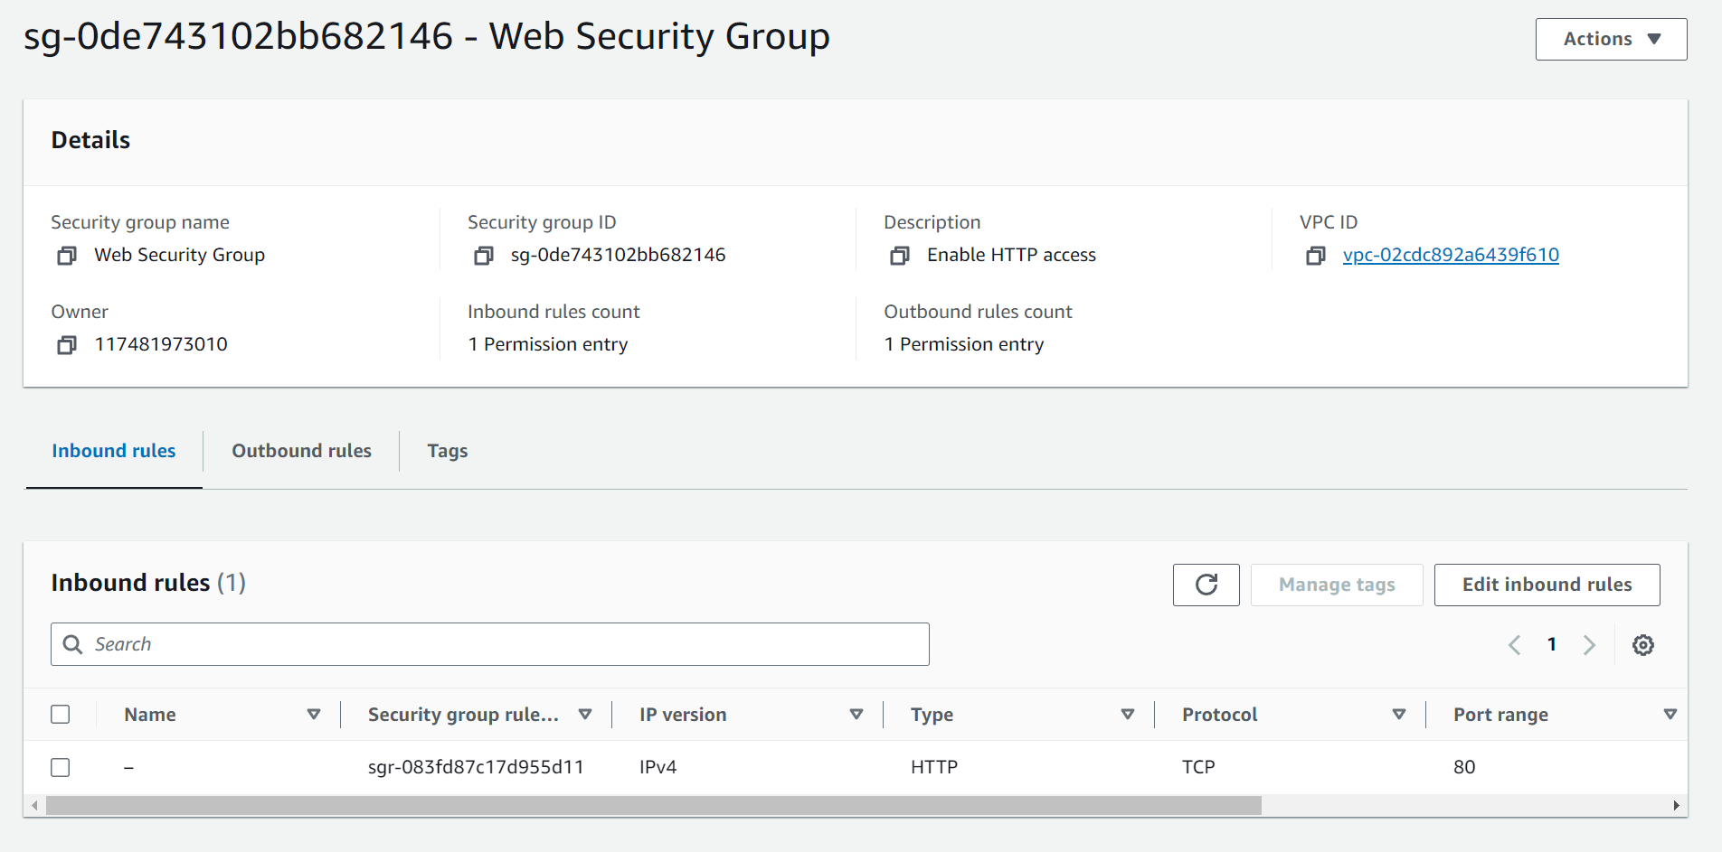

Finally, we will launch another AWS service into this VPC, specifically EC2.

Go to EC2.

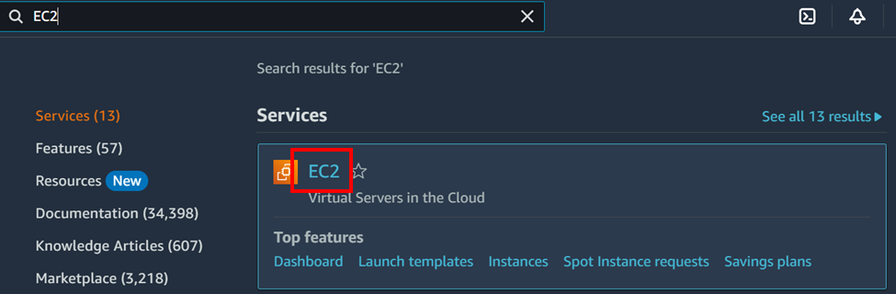

In the dashboard, press launch instance to start the EC2 instance.

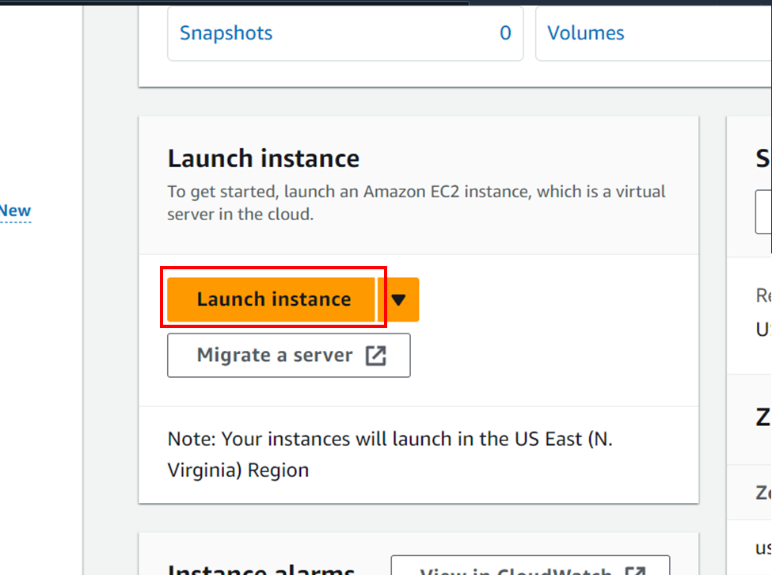

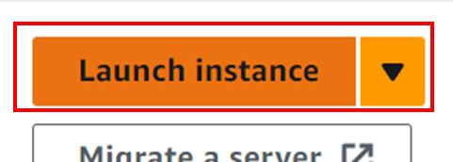

The configuration to launch an instance will appear. Start by setting the name to Web Server 1.

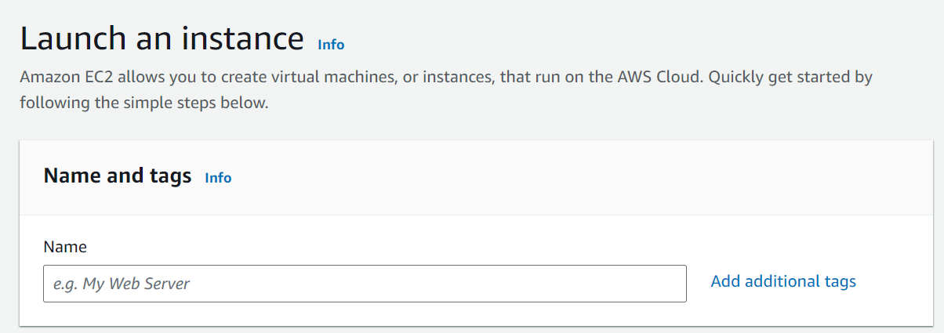

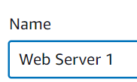

Keep the AMI and instance type defaults: Amazon Linux and the Amazon Linux 2023 AMI, and the t2.micro instance type.

For the key pair, select vockey.

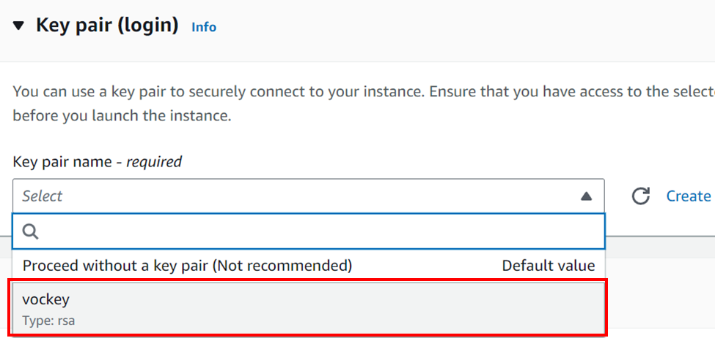

Under Network Settings, there is an edit button next to the header. Press it to modify the network settings including the VPC and subnet.

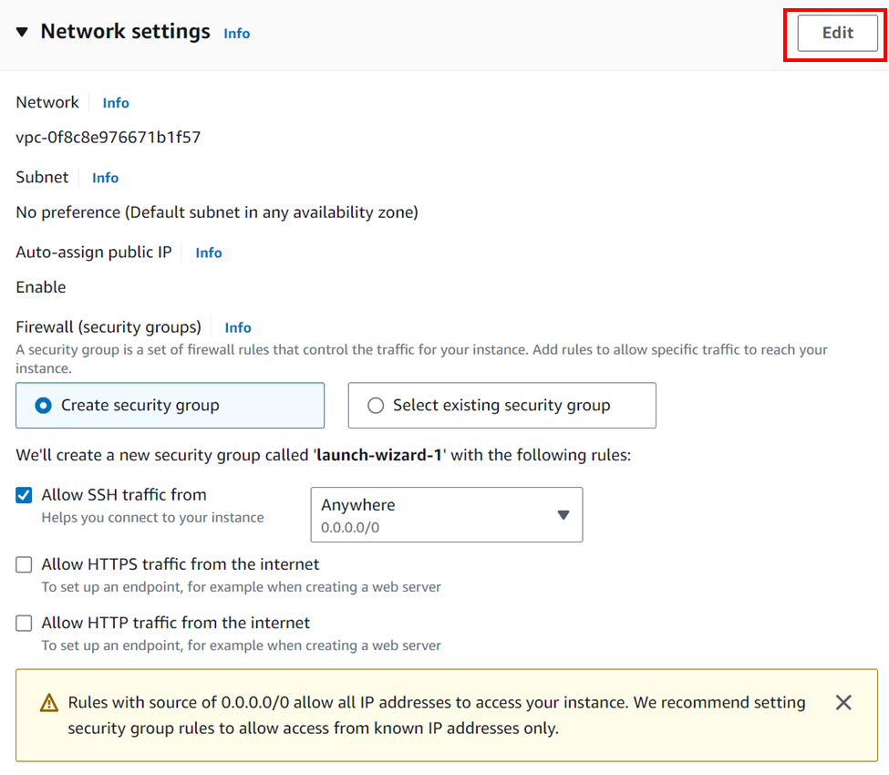

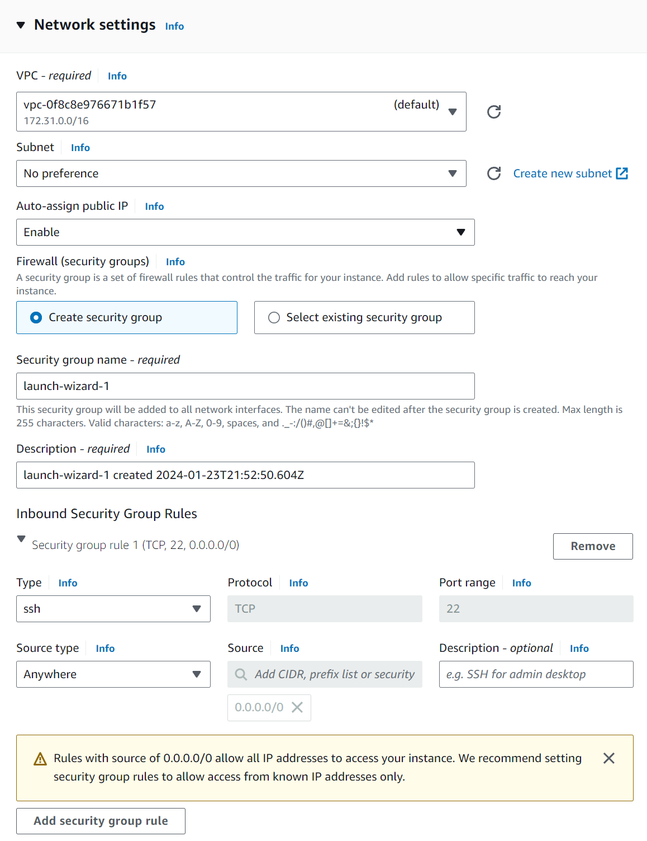

Configure the network settings as following:

* Set the network to lab-vpc (this is the VPC we configured earlier).
* Set the subnet to lab-subnet-public2 (do not use private, it will not work).
* Set Auto-assign public IP to Enable.
* Set Firewall to select an existing security group, so we can use the security group we configured earlier.

At this point, the configuration will look a little different from the image above.

* Set Common security groups to Web security group.

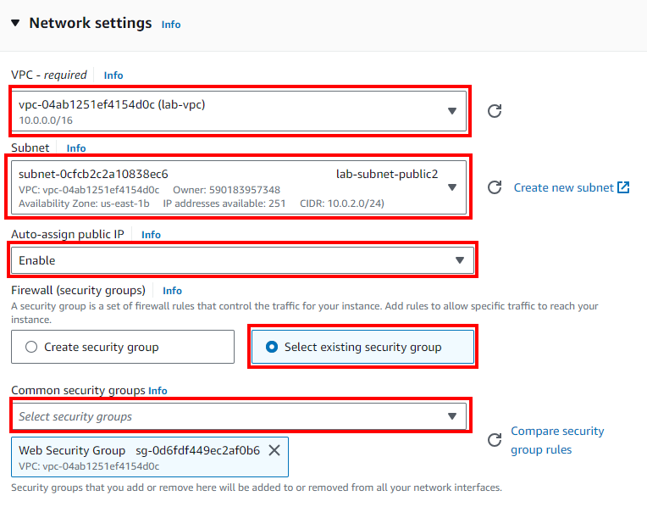

The network settings have now been configured. Next we will advanced settings.

Scroll down to and expand to the Advanced settings panel (not in network settings) and scroll till you reach User data.



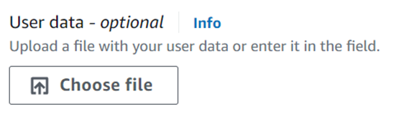

Paste the following into User data:

#!/bin/bash

# Install Apache Web Server and PHP

dnf install -y httpd wget php mariadb105-server

# Download Lab files

wget https://aws-tc-largeobjects.s3.us-west-2.amazonaws.com/CUR-TF-100-ACCLFO-2/2-lab2-vpc/s3/lab-app.zip

unzip lab-app.zip -d /var/www/html/

# Turn on web server

chkconfig httpd on

service httpd start

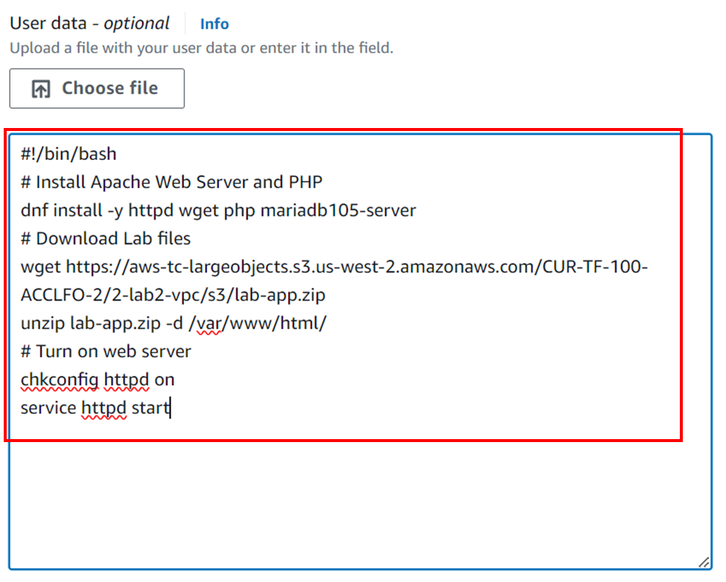

The Launch instance has been configured. On the right of the configuration there will be a summary panel, and at the bottom press the “Launch instance” button.

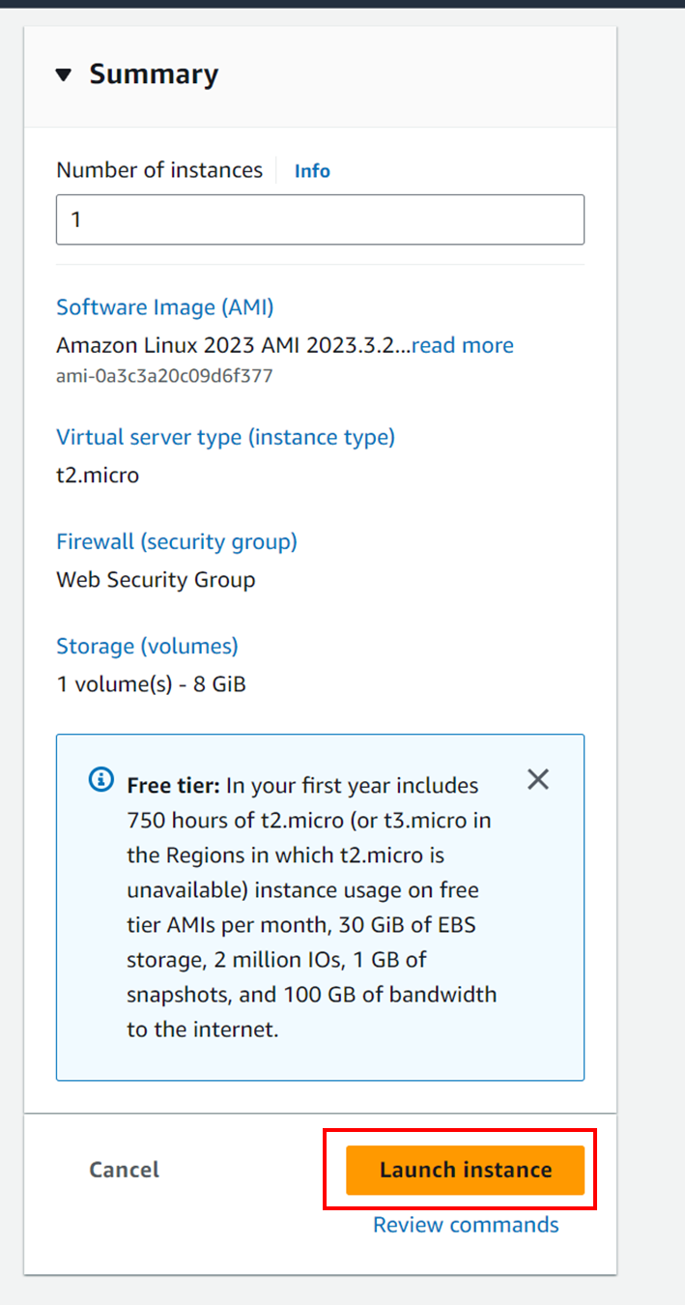

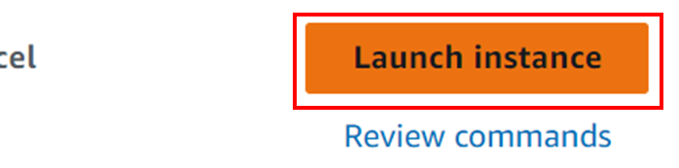

The EC2 instance has been launched.

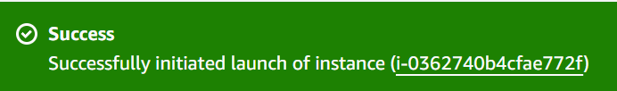

To check the status of the EC2 instance, click the “View all instances” button and check the “Status check” column of Web Server 1.

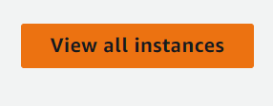

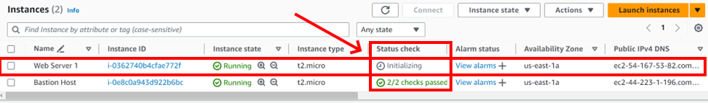

It will be initializing right after launching the instance, but reload regularly (every ~30 seconds) until it shows 2/2 checks passed. It most likely will take a while.

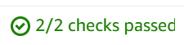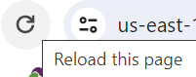

Select the Web Server 1 instance, and in the bottom pane will be populated with its information. On the very right of the pane, there will be a Public IPv4 DNS. Press the “open address” link to open this instance.

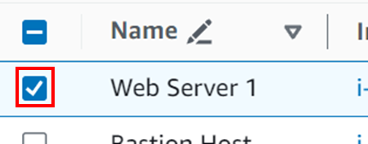

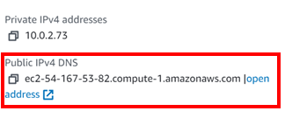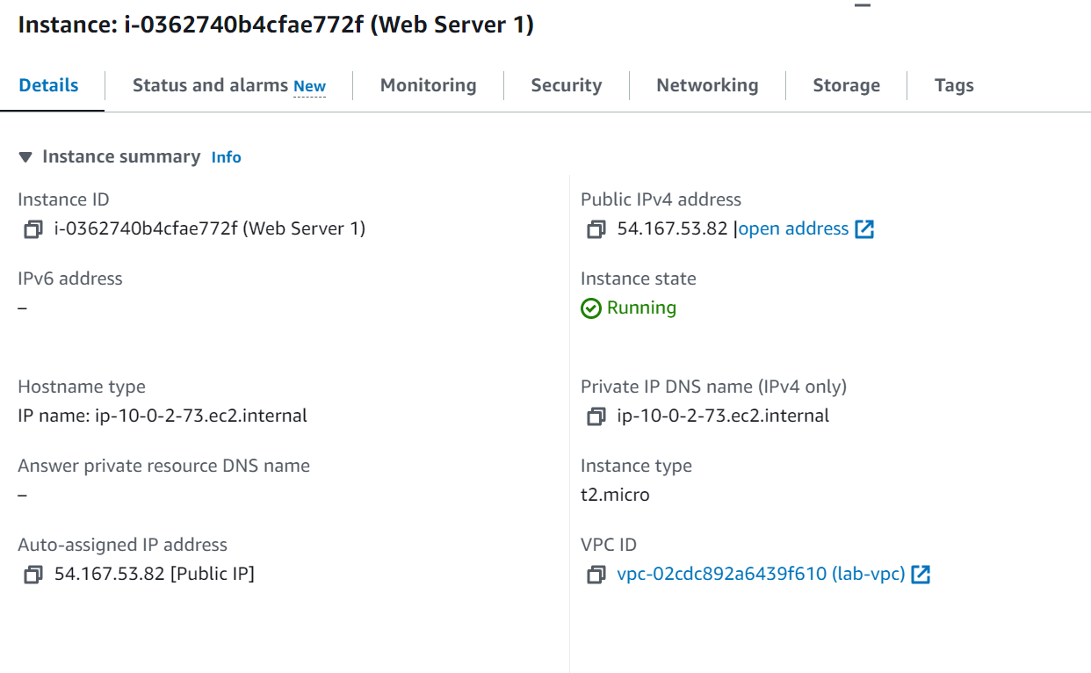

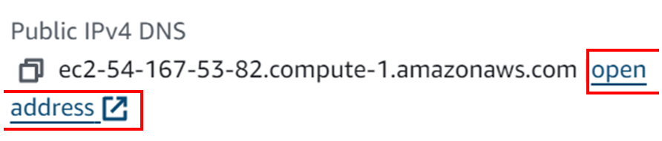

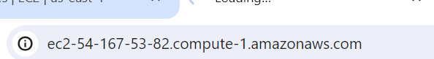

When it loads, a page similar to this should appear. When it loads it indicates that everything works.

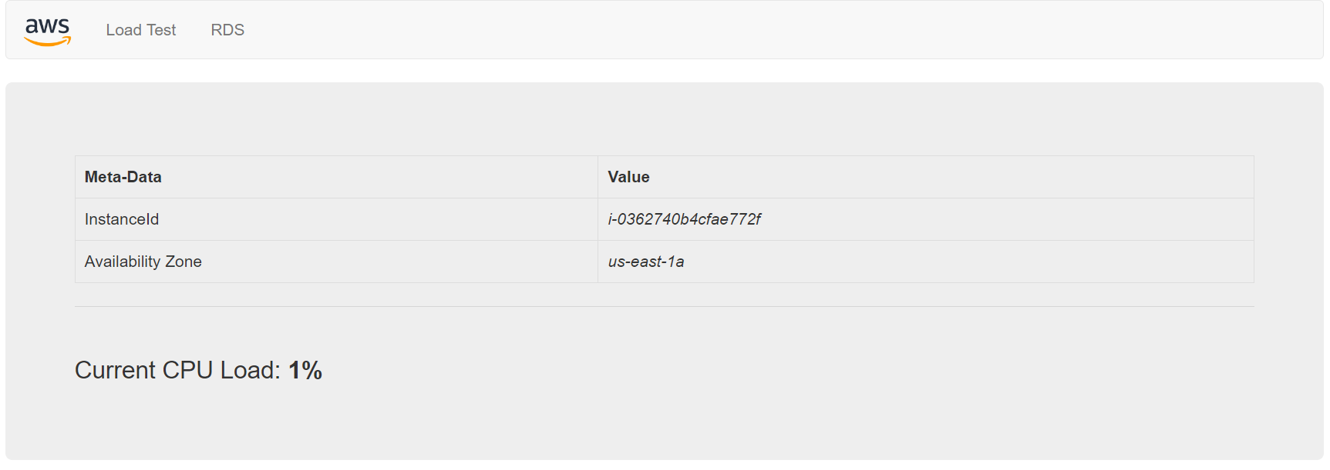

Lab 3 – Introduction to Amazon EC2

# Purpose

The purpose of this lab is to go further in depth into AWS’s Elastic Compute Cloud (EC2). It was introduced in past labs, but this lab will be focusing on it instead of using it as a placeholder for any resource.

# Background Information

AWS EC2 is Amazon’s solution for junk computing capacity. It manages the processing power of different AWS virtual machines to allow for dynamic configuration of processing power to easily allocate resources as needed. EC2 also provides resource monitoring so customers can accurately change their resource allocation as needed. It is also responsible for hosting applications.

# Lab Summary

In this lab we setup and launch a web server with termination protection, learn how to monitor this web server and analyze information from this monitoring, learn basic troubleshooting utilities, resize the EC2 instance, create security groups to configure how traffic is handled, learn how to see how many resources our AWS account can allocate, see termination protection in action, and disable termination protection to delete our EC2 instance.

# Configurations

Start by opening the EC2 console.

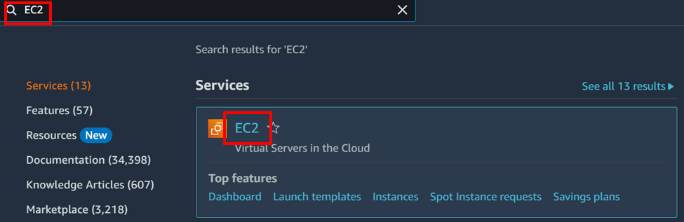

Press the “Launch instance” button to begin launch configuration.

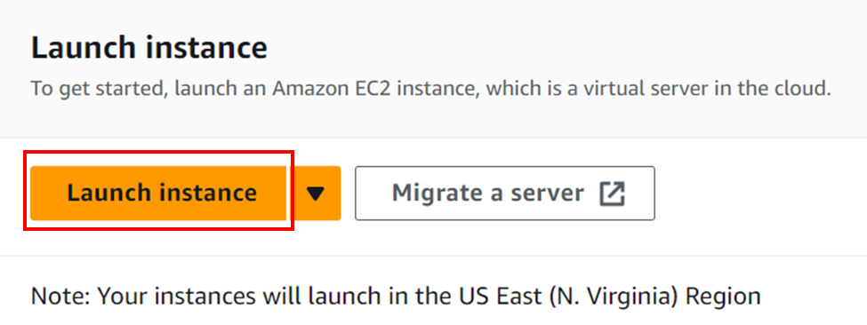

Configure the instance with the name Web Server.

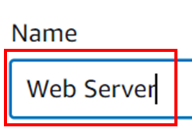

Keep AMI and Instance type configurations default.

Set the Key pair name to vockey.

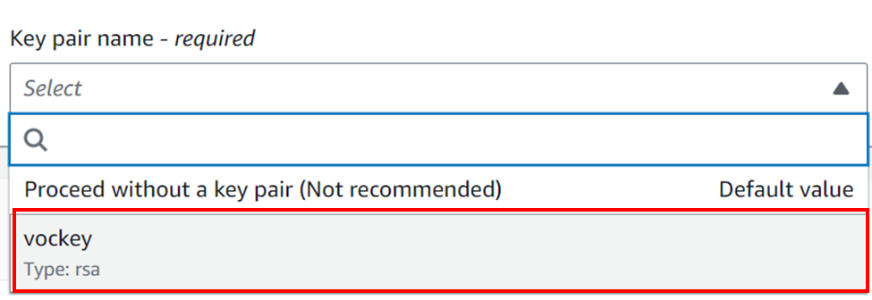

Press the “Edit” button next to the Network settings header,s and set the VPC to the premade Lab VPC.

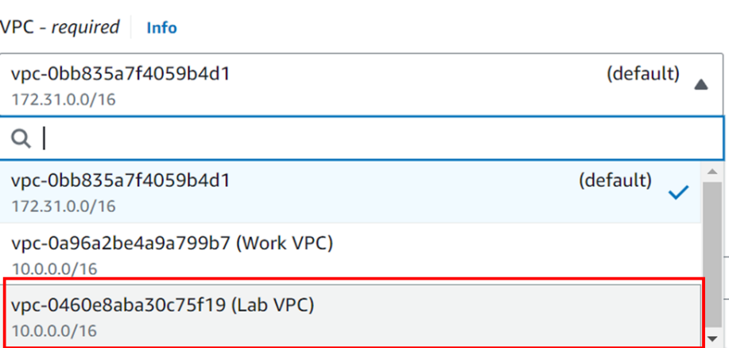

Create a new security group with the name Web Server security group, the description Security group for my web server, and remove the inbound security group rule.

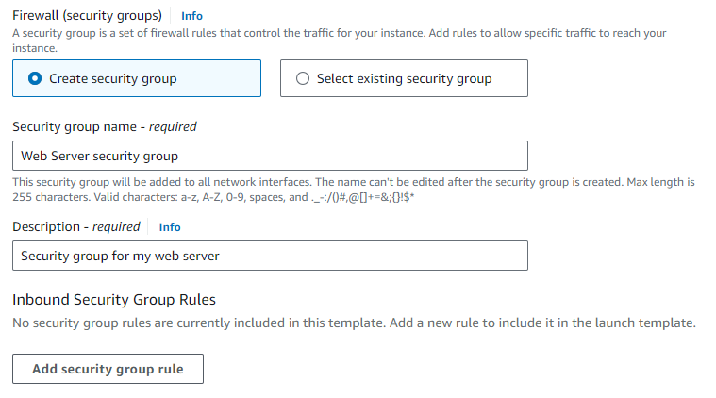

Keep storage set to default.

Expand advanced settings and enable termination protection.

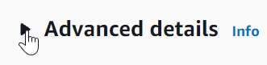

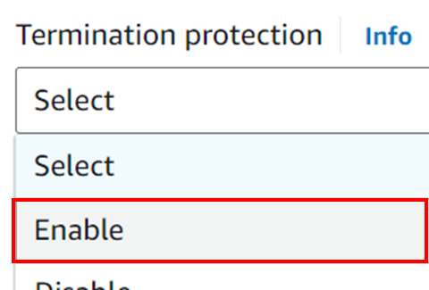

Scroll down until you reach User data and paste the bash into the text field.

#!/bin/bash

dnf install -y httpd

systemctl enable httpd

systemctl start httpd

echo '<html><h1>Hello From Your Web Server!</h1></html>' > /var/www/html/index.html

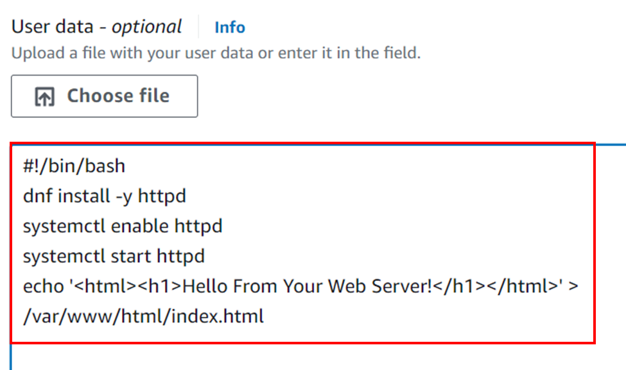

Launch the instance from the summary panel on the right of the configuration.

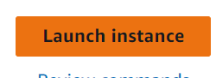

The instance should launch successfully.

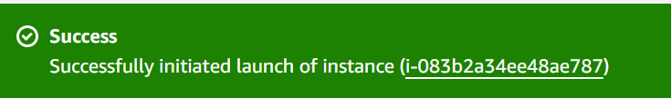

Go back to the Instance table with the “View all instances” button.

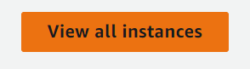

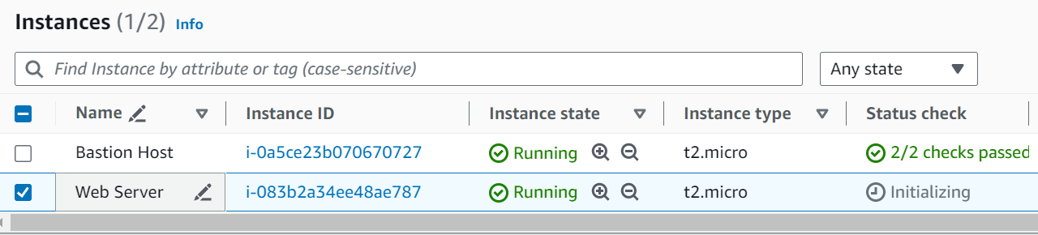

Select the Web Server so the bottom pane is populated with its information.

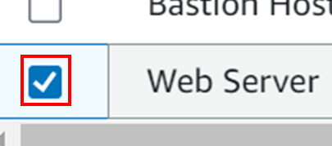

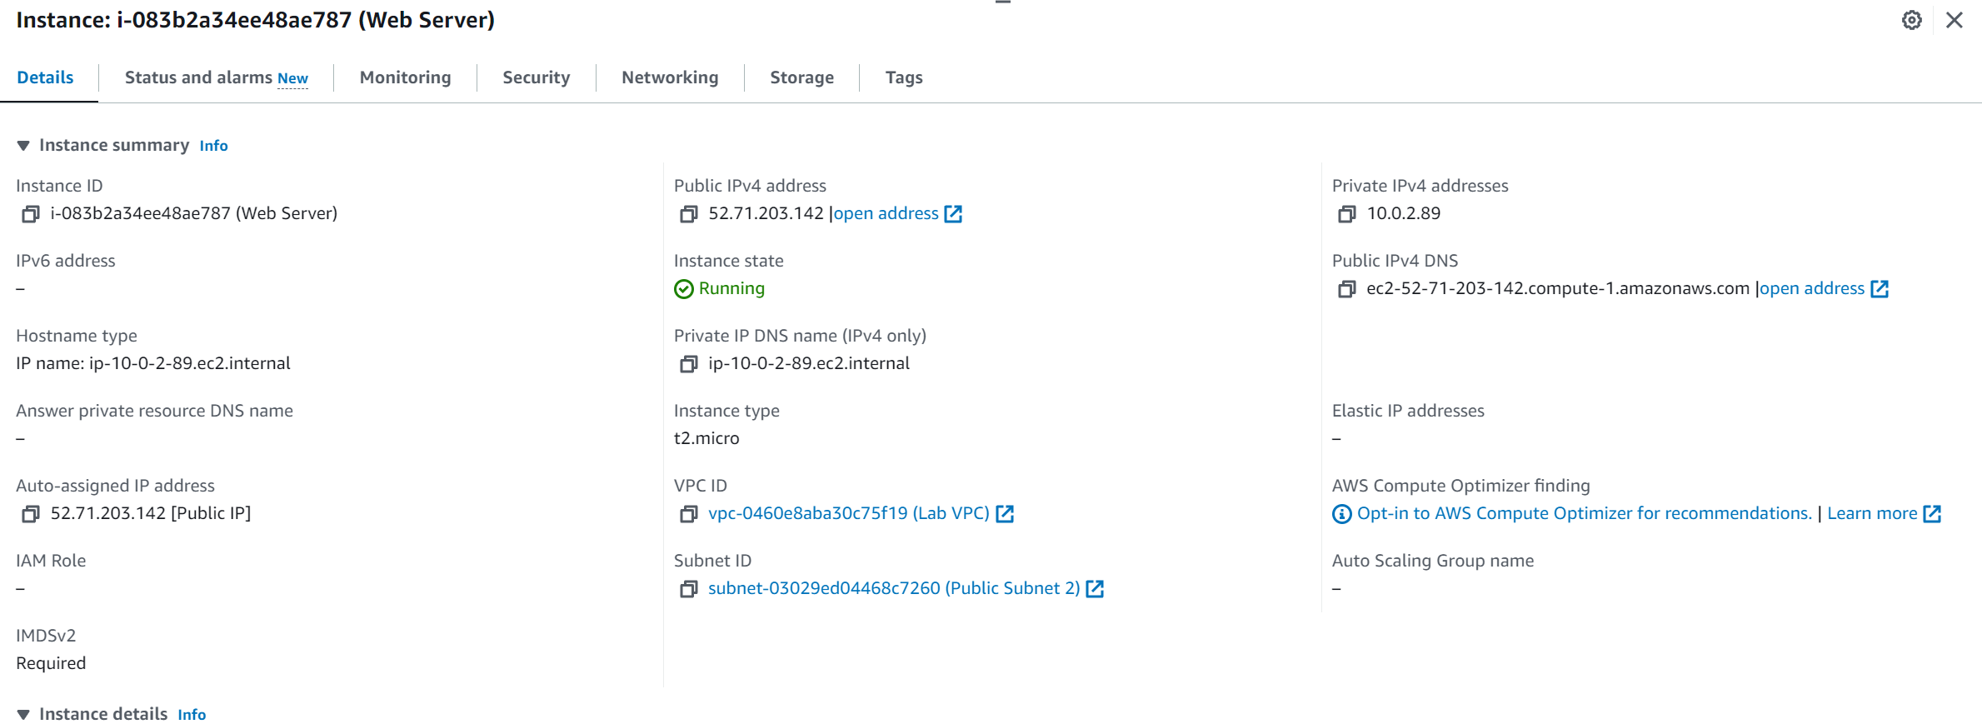

Wait till checks pass.

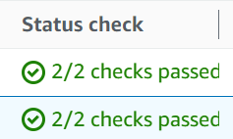

Now on to how to monitor the EC2 instance.

When checks pass, navigate to the Status and alarms tab.



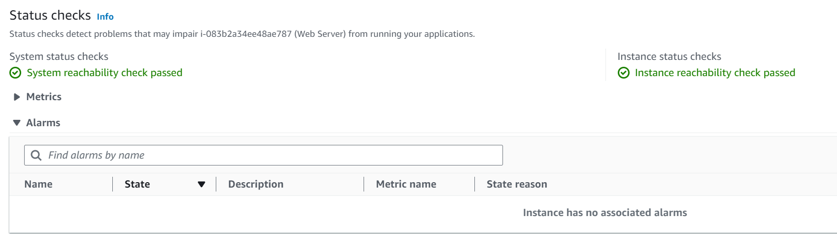

Here, we can see that both checks have been passed.

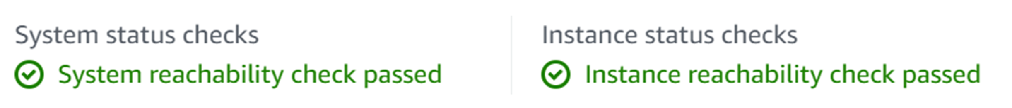

(Edited for visual purpose)

Navigate to the monitoring tab.

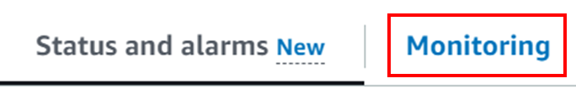

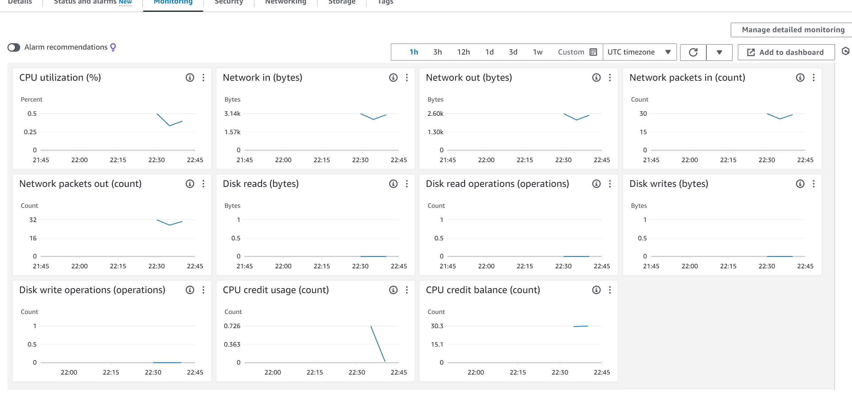

These are the CloudWatch metrics for this instance. The instance was recently launched, so there will not be much to see.

You can zoom in on any of these graphs by clicking the 3 dots at the top right of each graph and selecting Enlarge from the dropdown menu.

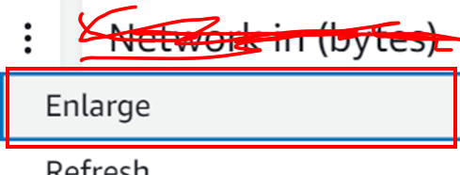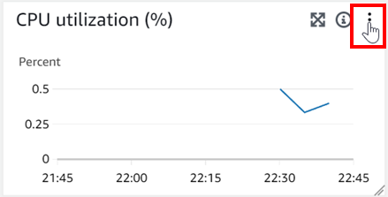

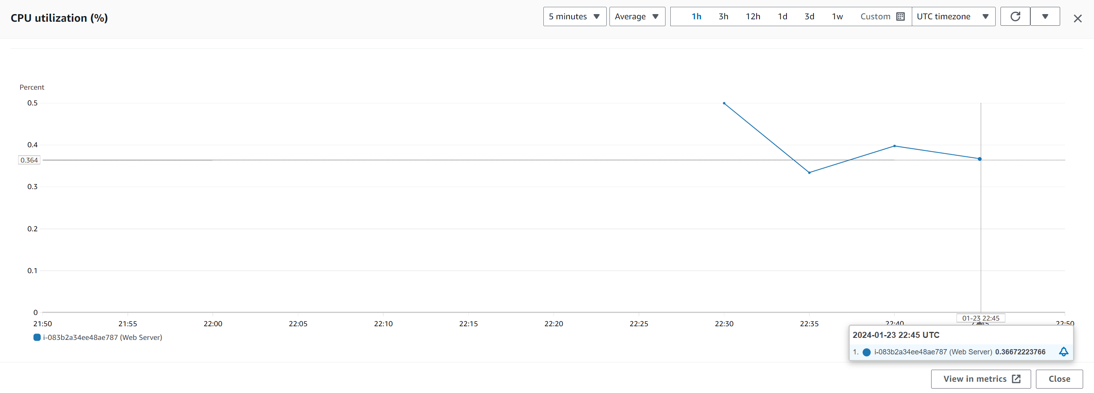

Press the x to exit the enlarged graph.

To get the system log of the instance, focus to the top right of the console and expand the Actions dropdown menu, then select the Monitor and troubleshoot then select Get system log.

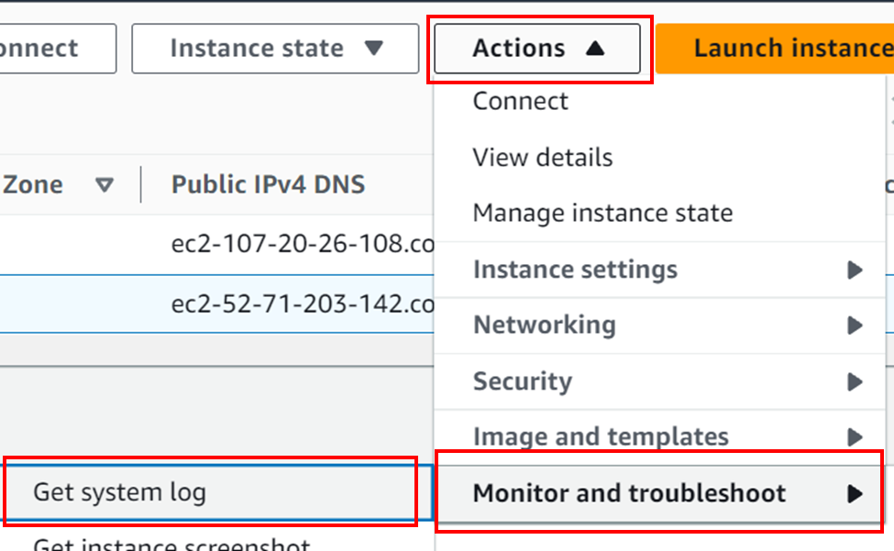

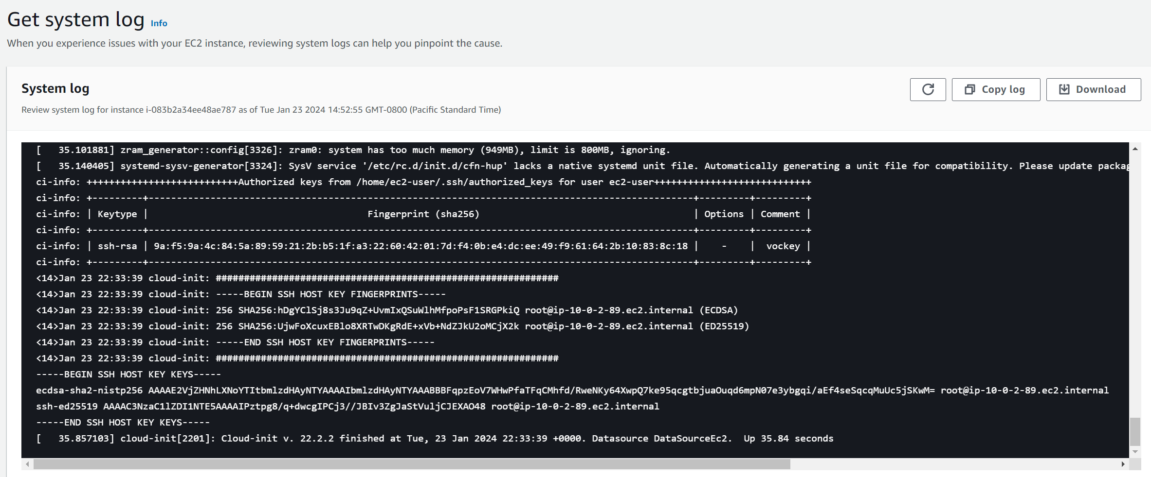

This is a useful tool to diagnose issues that cause the instance to terminate before alternate diagnosis options are available. It displays the console output.

Press the “Cancel” button to exit the System log.

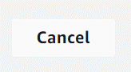

We can also get an instance screenshot to see what the instance console would look like if there was a screen attached to the server.

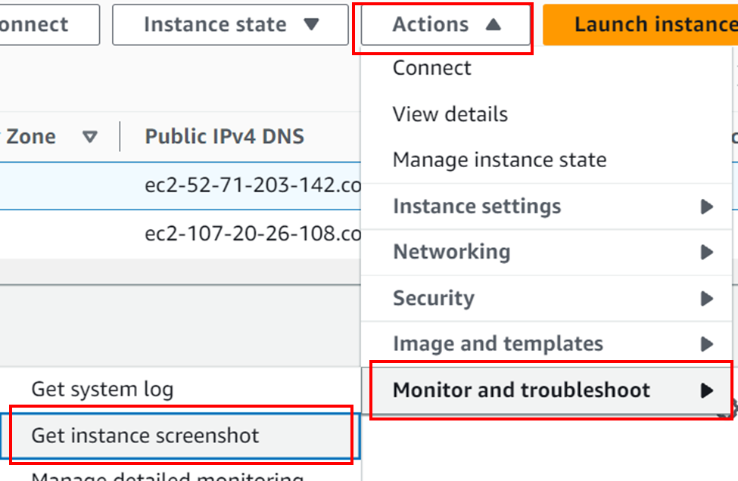

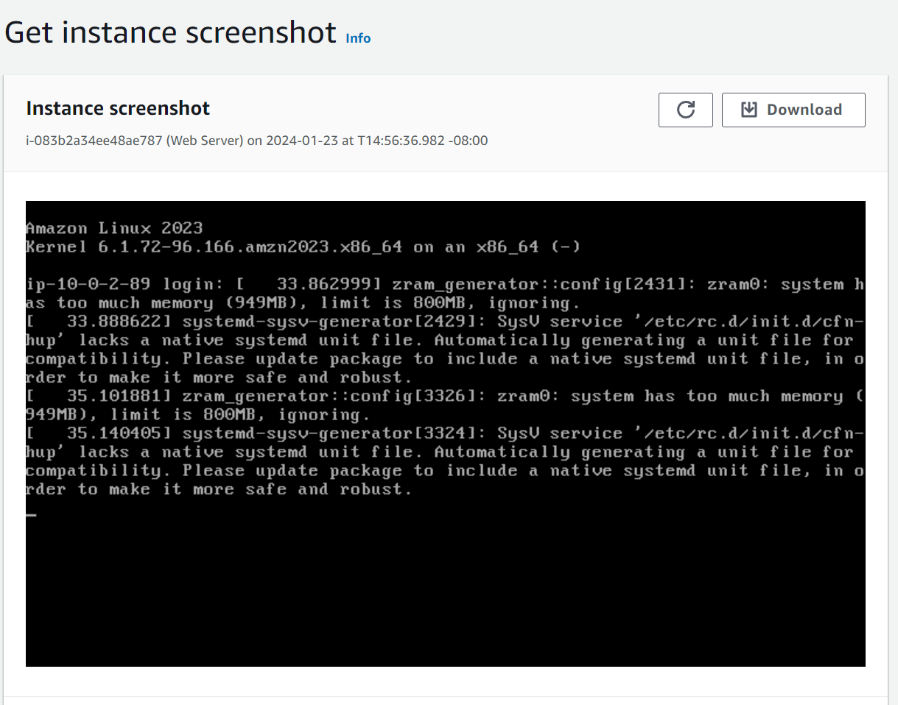

Press the “Cancel” button to close.



These are all several ways to monitor the EC2 instance.

Now, we will update the security group of the EC2 instance to let us access the web server from a browser.

Go back to the Instance table and reselect the Web Server instance.

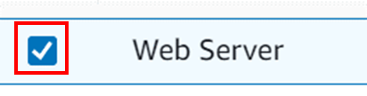

Open the address listed under Public IPv4 address with the “open address” link.

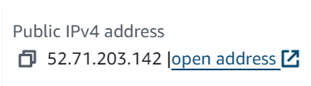

This IP will not respond, because we have not set up a security group to allow HTTP traffic to access the web server.

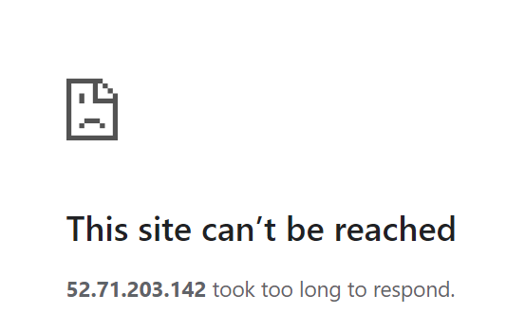

Return to the EC2 console and from the left sidebar, navigate to Security groups.

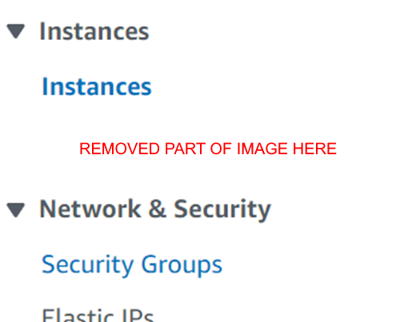

(Part of image removed for visual purpose)

A table listing all the EC2 instances will appear. Select the Web Server security group security group that was created when the EC2 instance was launched.

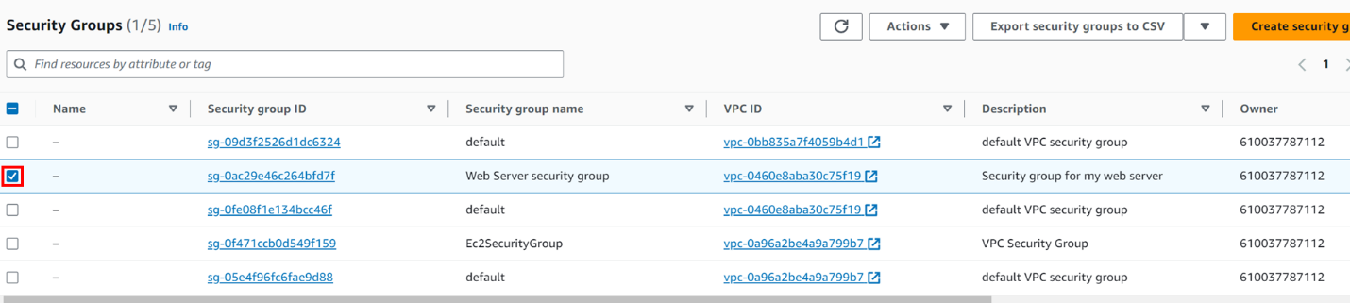

The bottom pane will be populated with the details of this security group. Navigate to the Inbound Rules tab.

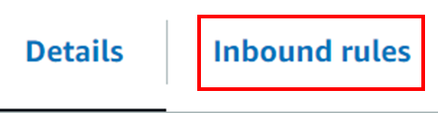

Since we deleted the inbound rule during the launch configuration, the group has no inbound rules.

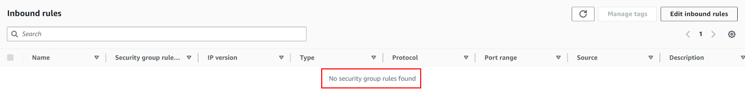



Click the “Edit Inbound rules” button at the top right of the pane and click the “Add rule” button to create a new Inbound rule for this security group.

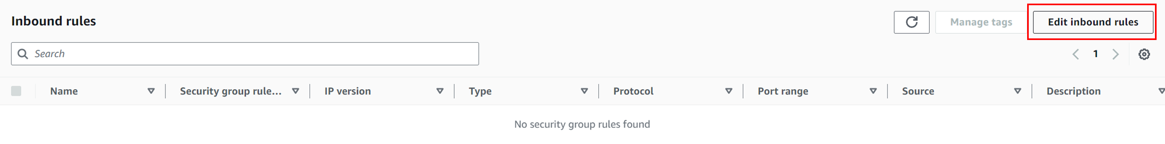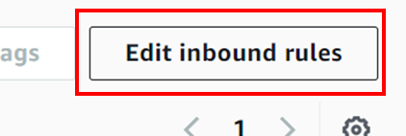

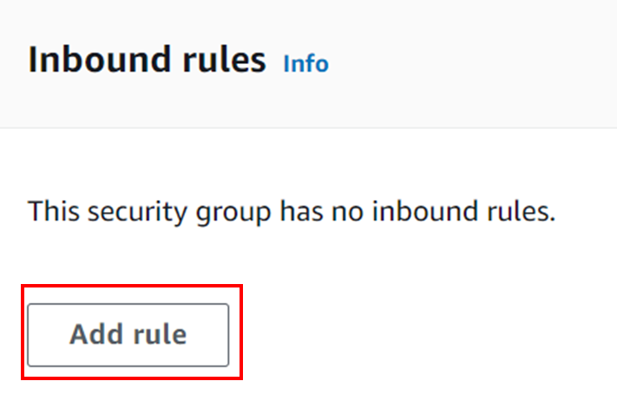

A new blank rule will be created.



Configure the rule with the following then save the rule to apply changes:

* Set the type to HTTP since we want to access the instance from a browser.
* Set the source to Anywhere-IPv4 to apply the rule to all sources.

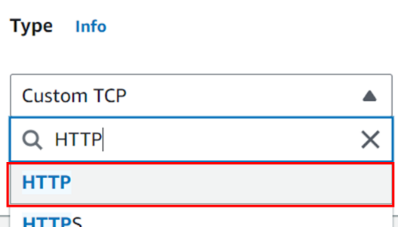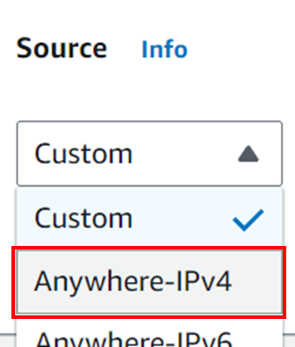

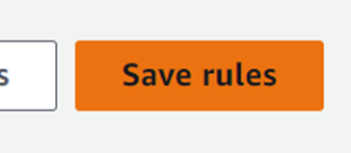

Reload the IPv4 address.



NOTE: Make sure you are connecting to the IP with HTTP, not HTTPS, or it will still not work.



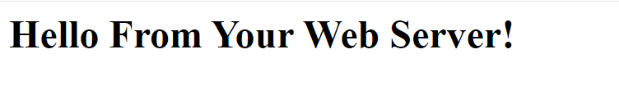

We will now resize the instance. This is important in the case where resources are not adequate. If it is too small, it will not be able to keep up, and if it is too large, costs will be higher.

We will start with increasing the memory.

From the left sidebar navigate back to Instances.

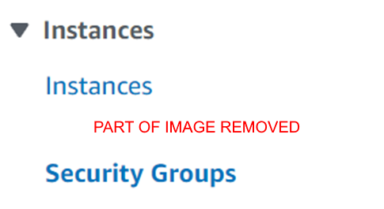

(Part of this image has been removed for visual purpose)

Focus on the top right corner, expand the Instances dropdown menu, and select Stop instance and press the “Stop” button.

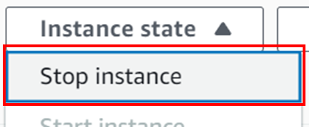

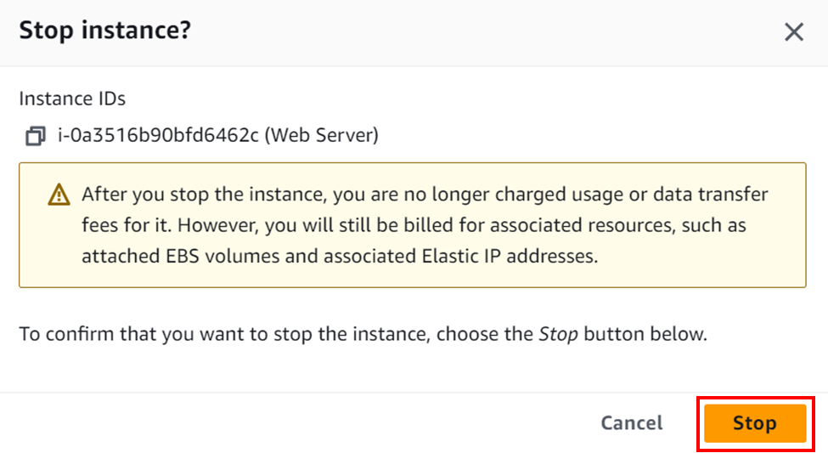

We need to do this because the instance cannot be resized when it is running.

Wait for the Web Server instance’s status to turn to Stopped, and select the instance.

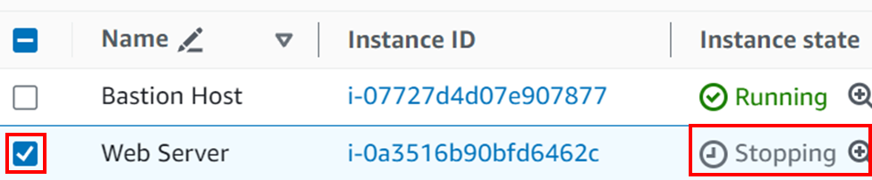

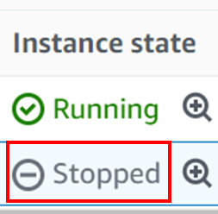

Expand the Actions dropdown menu on the top right of the table, go to the Instance settings category, and select Change instance type.

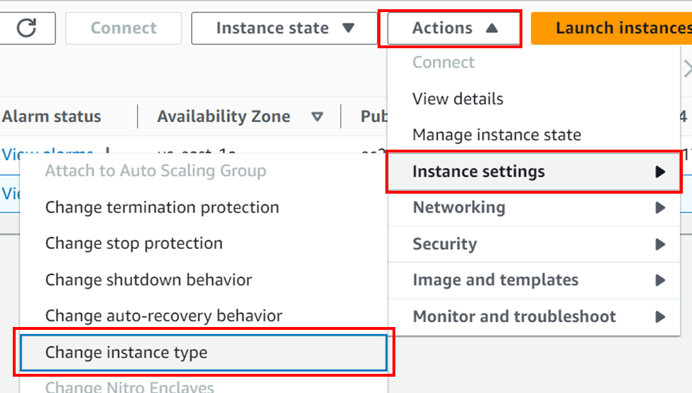

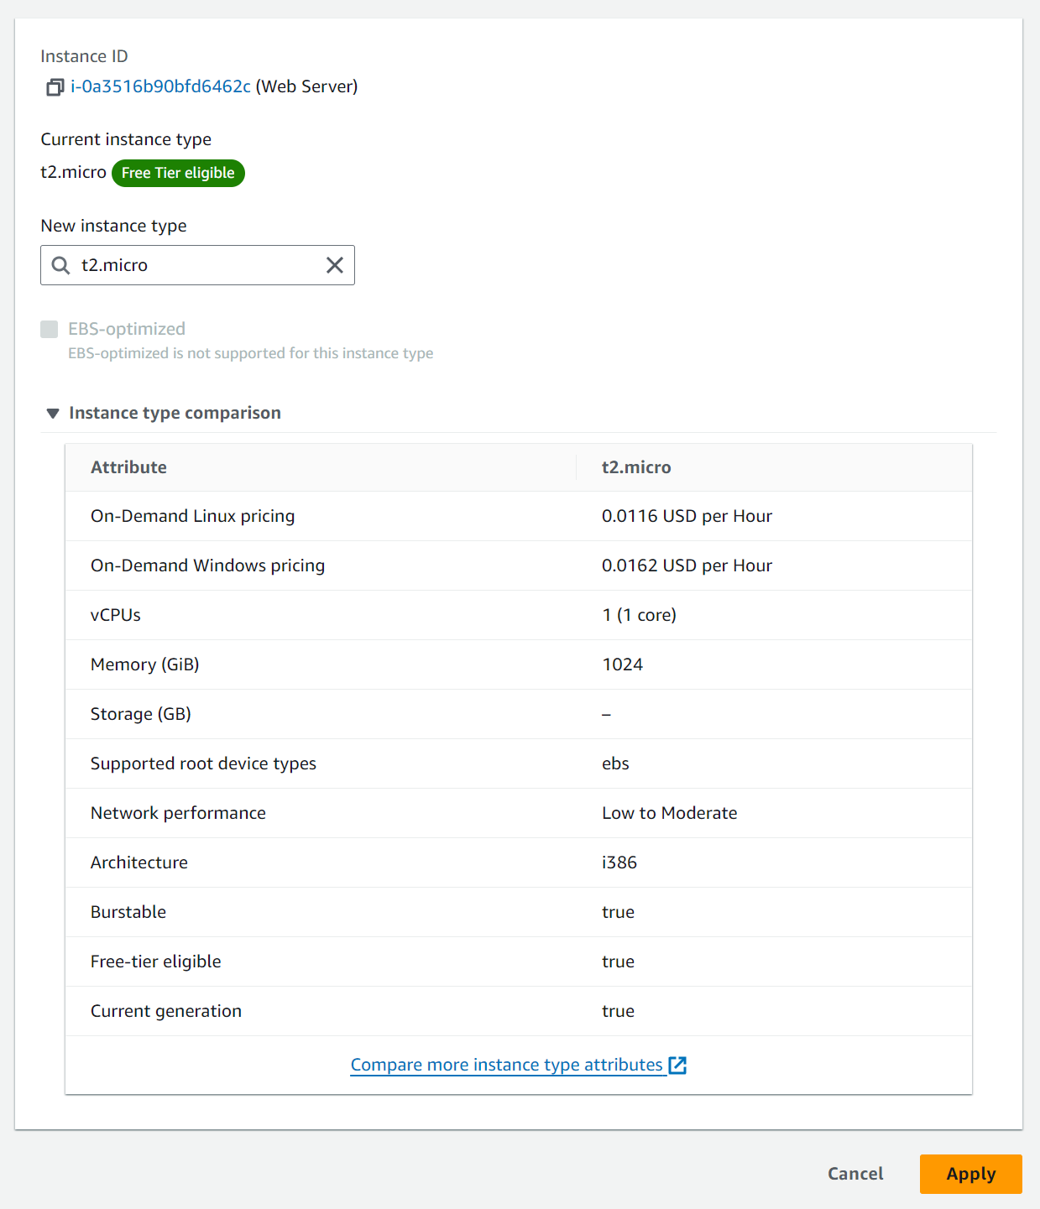

This page should pop up. Set New instance type from t2.micro to t2.small, then press the “Apply” button.

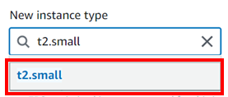

The instance will have twice the memory the next time it is started.

We will now increase the storage the instance has.

Reselect the Web Server instance, and navigate to Storage tab.



A table with the volumes in the instance will appear. Click the link of the only entry, then select the only entry of the table that is opened from the link.



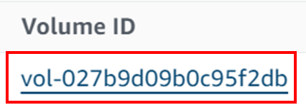

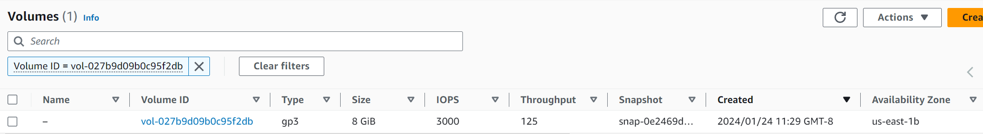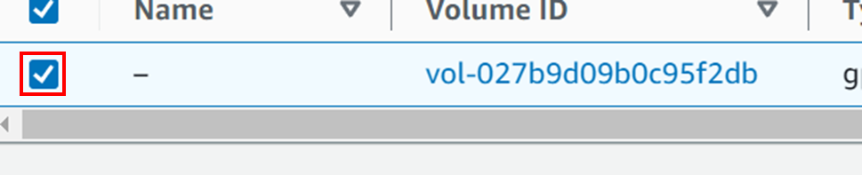

From the top right corner of the table, open the Actions dropdown menu and press the “Modify volume” button.

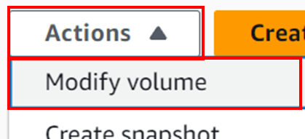

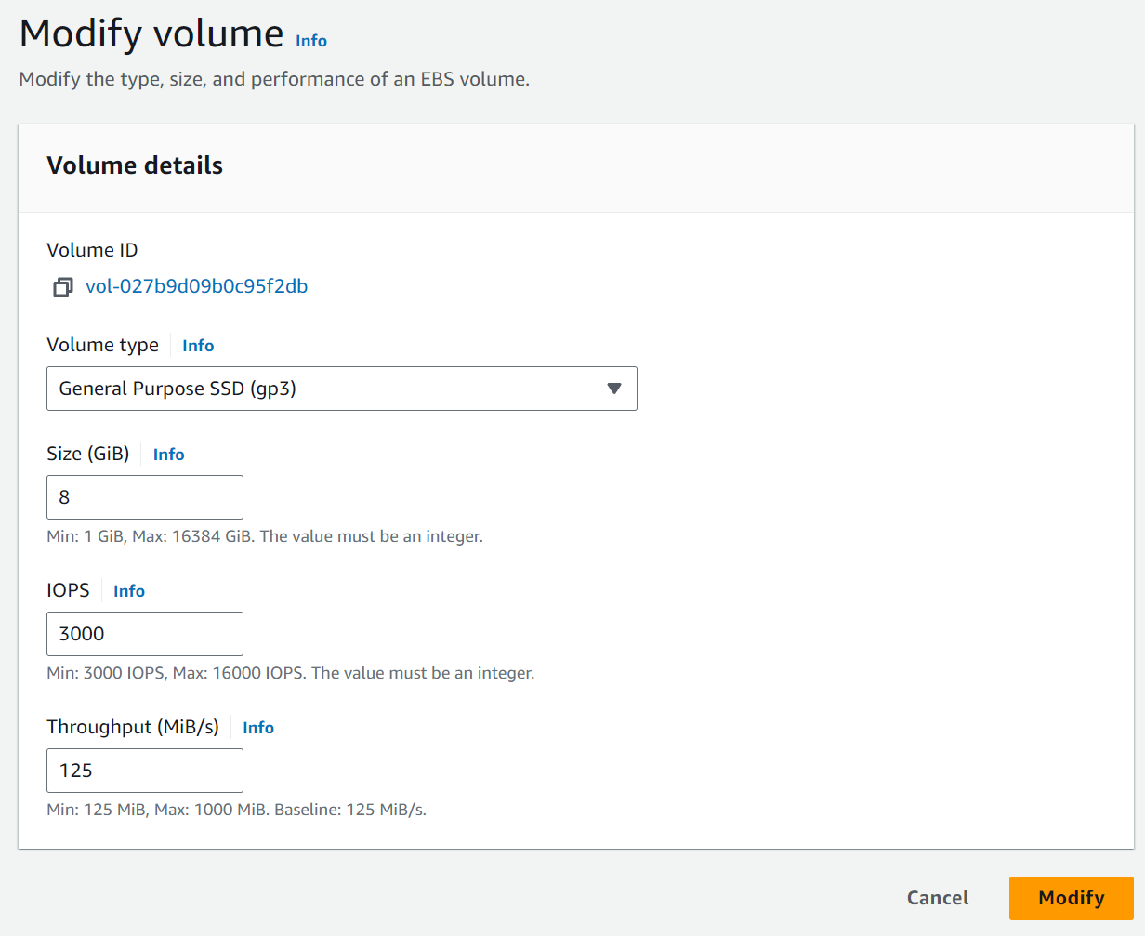

This page will appear. Change the Size from 8 to 10 GB and press both “Modify” buttons to apply changes.

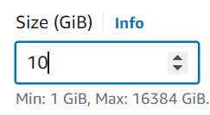

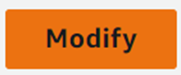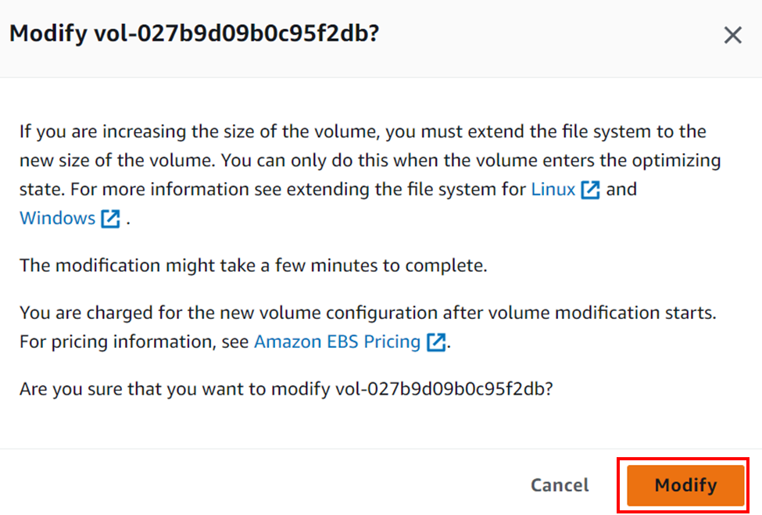

Go back to the Instances page and from the Instance state dropdown menu, select Start instance.

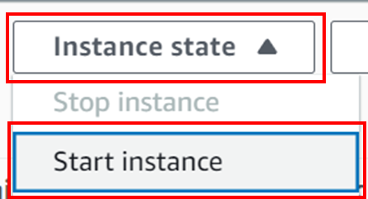

Wait for both checks to pass. The instance should now have double the memory and 2 more GB of disk space.



Now we will look at the maximum resources we can allocate at once per region.

From the search bar go to Service Quotas.

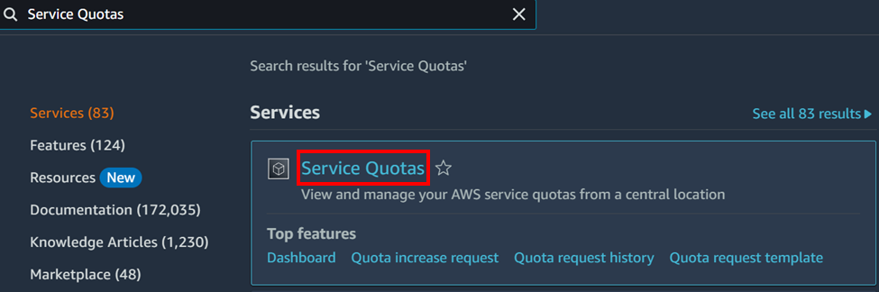

On the left sidebar go to AWS services.

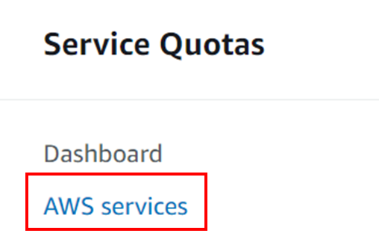

A search bar for AWS services will appear in the body of the page. Search for “Amazon Elastic Compute Cloud (Amazon EC2)”.

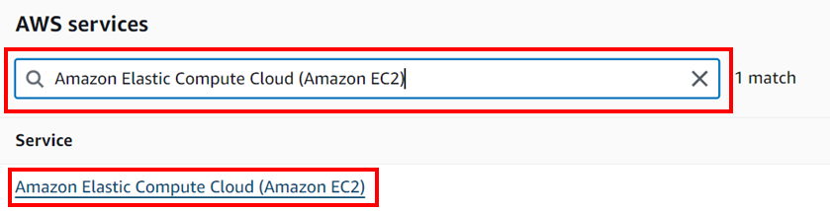

Another search bar will appear for service quotas. Search “running on-demand”.

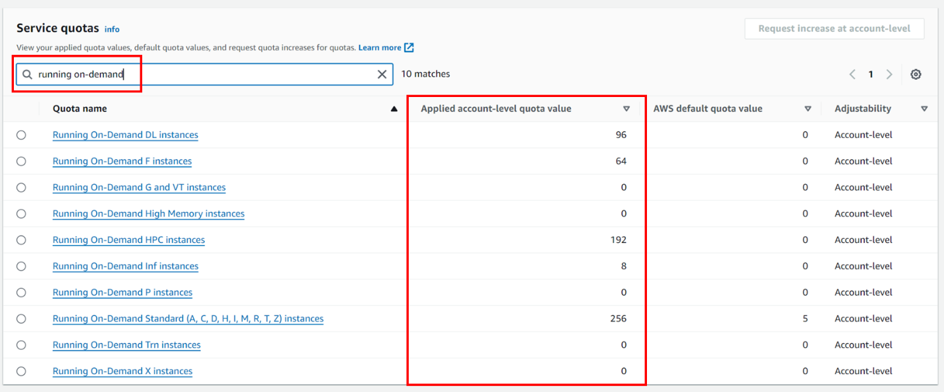

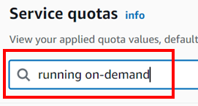

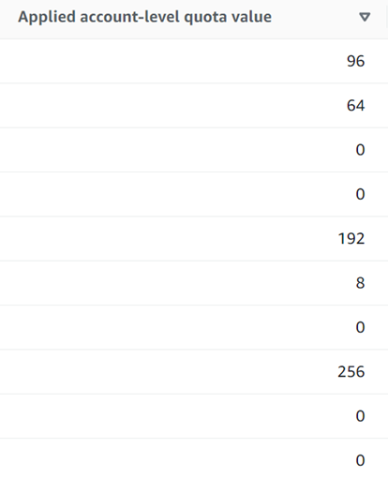

Notice there are limits for each service. These cannot be exceeded per region.

Finally, we will test termination protection.

Return to EC2 and go to Instances, select the Web Server instance, then from the top right expand the Instance state dropdown menu and select Terminate instance.

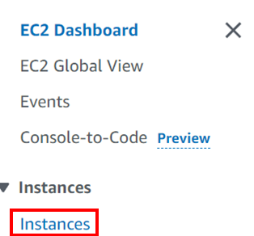

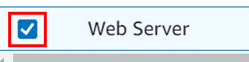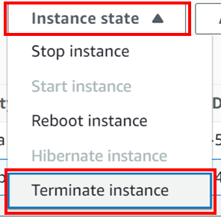

Press the “Terminate” button. As we can see, the popup is already warning us of termination protection being enabled.

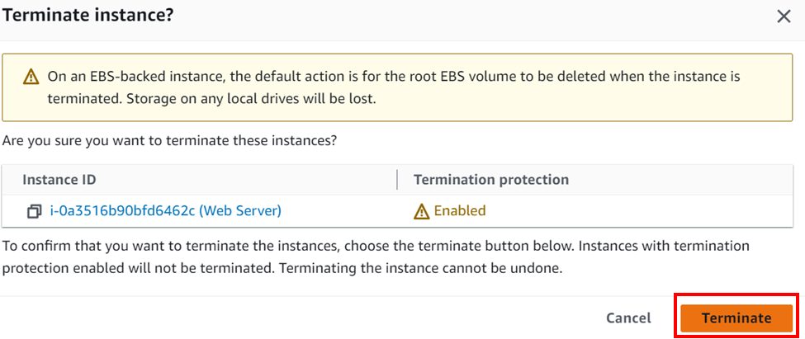

We will get this error.



Now we will disable the termination protection on the Web Server EC2 instance and try to terminate it again.

Expand the Actions dropdown menu, open the Instance settings category, and select Change terminal protection, then uncheck the Enable checkbox and press the “Save” button to disable termination protection.

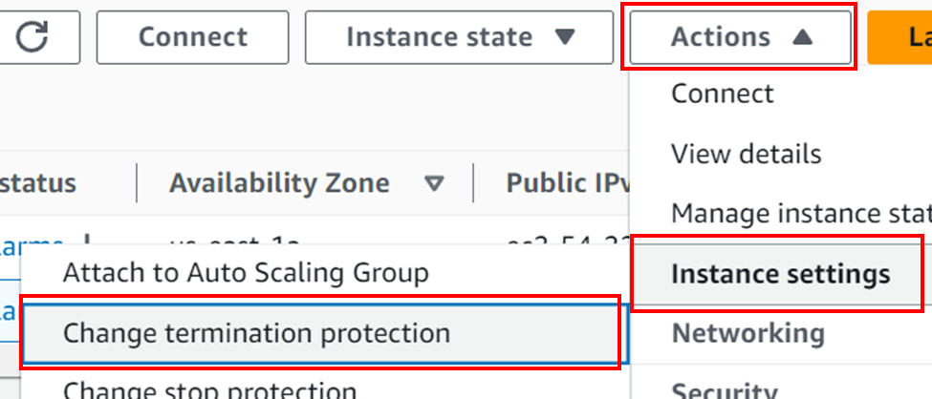

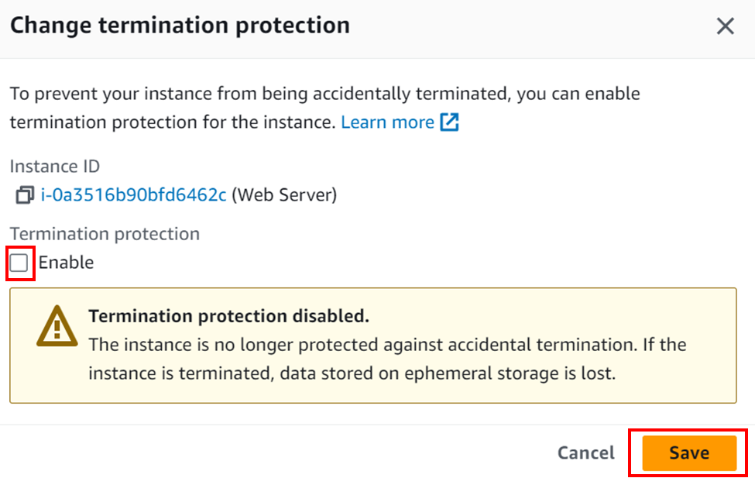

This message will appear



Try to terminate the instance again, and this it will return successful and begin deleting the instance.



Conclusion

# Problems

Some problems I encountered was getting the labs to work. After pressing Start Lab on the AWS Academy page, much of the time after the lab was ready, after going to the AWS console the lab was broken and I could not follow the steps and progress. For example, on the first lab, when I went to the IAM page, it showed there were 0 users and 0 user groups, when there should have been 4 users and 3 user groups. Another problem I encountered was my browser defaulting to HTTPS, when the security groups only allowed HTTP traffic through. This was just an error on my part, but it took a while to figure out.

# Conclusion

These labs introduced essential AWS concepts and services to new AWS customers. Three services were covered – IAM, VPC, and EC2 – which are all essential when working with AWS. The labs were a lot of busy work, but they were effective in getting a good grip on using AWS.